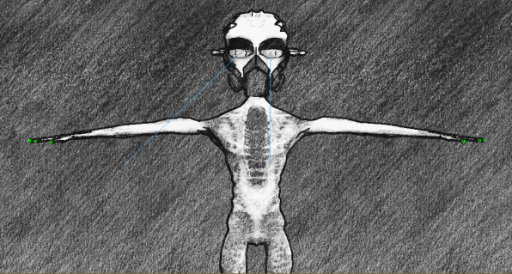

FINAL YEAR PROJECT
Enyinna Ezebuiro
1138242

CREATING IMMERSIVE CHARACTERS THROUGH 3D ANIMATION AND HUMOUR
Project Clint

CONTENTS:

AIMS:
To produce an animation with immersive, interesting and funny characters through the use of 3D software.
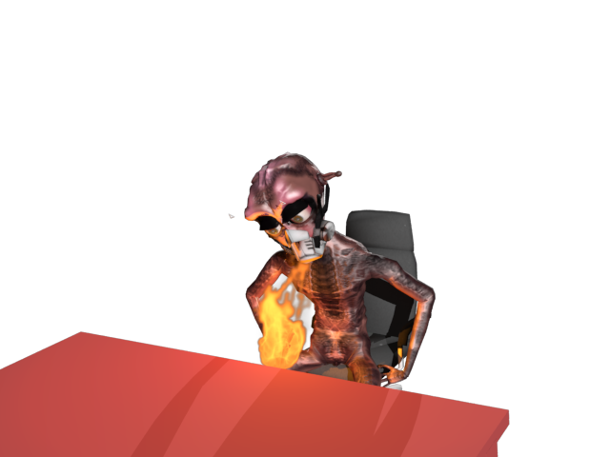
To keep an audience entertained.

Objectives:
- Using 3D animating, motion capture and sound software to produce the trailer’s characters and bring them to life.
- Create a short 3D animation for a videogame trailer.
- Combine research of different types of animation simulating.
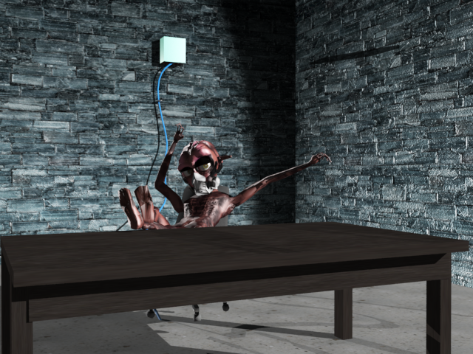
Abstract

Motion capture is rarely ever performed to create funny, eccentric and fantastical characters to be brought to life within film or animation.
Yet I challenged to create an indulging character full of fun and life, to be brought towards the audience to bring laughter and smiles; whilst using motion capture that no-one dares to use for such an effect.

‘Project Clint’ campaign report
Introduction

My dissertation piece will be based on a videogame trailer, called ‘Project Clint’. I will not actually be creating the game itself, but more-so one of the main promotional feats that go with the game. So this would be conceptual designs of the game and characters within it, promotional artwork perhaps ranging from posters and digital wallpapers, and most importantly a game trailer to advertise the game as main pieces of work towards my dissertation.
In terms of the promotional elements within the campaign, if I create the digital posters and wallpapers they will need to be very aesthetically pleasing to the eye, especially older teenagers who will be my main target audience. My alien Clint will be a very quirky and eccentric being; therefore the promotional work will need to be a clear reflection of this in order clasp a solid audience that knows exactly what they’re in for to anticipate the game and my character. If the marketing work can capture the essence of his character well, then audiences will rack in for a taste of what’s more to come by the full product’s arrival.
He needs to be clearly associative with extra-terrestrial and futuristic elements as those are strong themes to my designs and concept of work. The animation trailer will be to pose as the game’s main trailer advertising the game and enlightening my audience about the characters a bit, to give them a sense of who they are and who the protagonist is. Originally I had an idea of working on two trailers, one trailer posing as a teaser trailer for audiences to come together to await more from the product, and the other will be an official trailer to give audiences a more developed and in-depth insight to the characters and how they behaves, and a bit of what they have been up to. With this it will be helpful in giving everyone a taste of what’s to come and what to expect from the videogame when it is supposedly released.
For choosing comedy as the target of genre for my artefact the choice was simple. Comedy is more approachable by a wider range of audiences, whether young or old. Everybody loves to laugh! However it can be argued that not everybody is a big fan of romance, action, horror, documentary etc. Comedy is loved more all -round and therefore chances are it will be for animation as well. Competition is actually extremely high as comedy within animation by far the most utilised.

Why choose aliens?

I was easily able to choose early on to make my game’s protagonist an alien, when formulating ideas for my theoretical videogame.
With aliens there is no hard and solid evidence to whether they actually exist, however there is no certain proof to disprove their existence either. And if they do exist then to our information we know absolutely nothing about them. Nothing about their biology or origins, about what they can do, their habits, their intelligence, their abilities and instincts, whether they are good or bad or are like us with complex personalities that can’t be defined so easily by such in a ‘black and white’ manner. They are in their entirety a mystery to us, and we’ve always longed to learn more about them.
This is what made them an easy decision for me to choose one as a main subject towards my project. Their fantasied status would allow their capabilities to break all limitations that would usually and logically be bounded by our minds with creatures that do exist. In other words I can let my imagination run completely wild with the alien I’ll be creating, and it can’t be faulted for being too unrealistic or obscure as for all we know this one could legitimately be how they would be in real life. It works within the sense of inner logic, and therefore increases my chances in producing a truly immersing and interesting character.
With this knowledge it helped me to decide that alien(s) would definitely be the focus of my work in a way, as I know a successful game always possesses a main character of interesting and innovating imaginations. Making their story and the world they consist in remarkably interesting as well, and amazing to interact with as the player.

RESEARCH

The Protagonist: What type of a protagonist will Clint be?
To determine what kind of personality and characteristics my alien would possess, I decided to compose some secondary research into types of heroes featured in fictional stories. I composed a selection of information branching out the main ones I would consider.

Paragon
The paragon is a the stereotypical ‘good guy’ hero, presented in a numerous amount of fictional stories and is perhaps the most traditional thought when the term ‘hero’ is called. They never stray from the right path consciously, and will do whatever they can to put others first and stop evil at all costs; in many dramatic cases sacrificing their own lives if they have to.
Anti-Hero
Unlike and opposite to the paragon, the anti-hero is very multi-dimensional and holds several of layers to their character. They are good at heart but find it difficult to play by the books. Sometimes when they need to get something done they will break the rules, and take things into their own hands in order to get their own way. They are still the hero we all need, just not the one we expected.
Superhero
The classic hero with supernatural abilities that is great enough to save the story from demise and mayhem. Their unique powers climb them to the top of the pedestal, ensuring they are the chosen one to carry out the task of protecting everyone and saving the day.
Tragic Hero
This type of hero will always possess a flaw or set of flaws to which they cannot deal with or overcome. With this it will inevitably lead to their unfortunate expiration and/or failures by the end of the tale.
Chosen One
The chosen one already has their destiny set and paved to them through the story, they just have to figure out the best route to get there to discover where they will be taken and what fate has in store for them. Usually their ambitions are already laid out in front of them, and any other underlying goals are set to the side, even in extreme cases of a love interest or their self-preservation. They do whatever that must be done to fulfil their destiny.
Idiot Hero
The idiot hero is the usually the guy to which can’t do anything right, at least not at first. They are often very silly, and the audience will mostly laugh at them rather than with them. But their motives are right, and their heart is pure; even child-like, to do good. They are naïve, gullible and quite frankly unreliable but their stupidity usually proves for boldness. Perhaps because they are too stupid to realise the dangers and troubles they are in for, or perhaps they are just too dumb and blunt to care. However their ‘act first, think later’ mentality usually attests to be not only entertaining but inspiring in ways too. As they become the finest examples of ignorance being bliss, taking the term into their own heroic defining.
The idiot hero may use a common ploy often seen in many fictional and light-hearted stories, known perhaps as the ‘Indi-ploy’ (http://tvtropes.org/pmwiki/pmwiki.php/Main/IndyPloy). When their back is against a wall they may come up with a plan they are certain and confident in, enough to sway comrades and followers to be confident in them even with all knowledge of their idiocy. Yet it is discovered their plan was not a plan at all, but rather a lucky fluke waiting to happen that they did not even know of themselves. It is this silliness and charm that indicates the uncanniness of their love appeal amongst their audiences, making them often favoured and centred beyond all characters.

Clint’s category of Protagonist
I chose to create a hero with a mixture of many of these characterised attributes; to flesh out my character as much as I can, however make sure that his composition of personality all moulded seamlessly with one another. The ones I chose consisted of the anti-hero, the superhero, the tragic hero and the idiot hero.
I believed that the paragon was simply too one-dimensional and although traditional, risks the effect of seeming boring and out-dated even. The animation and character I wish to be creating needs to feel fresh and original, therefore I avoided taking my protagonist down this route of character.
I chose to utilise the attributes of the anti-hero, due to his several unconventional layers providing a more interesting depth to his character and plot. Audiences won’t be able to expect what Clint will do, and even though he will appear more on the bounds of good than bad he will ensure to push those boundaries as far as he can to keep away from general confinements. Whether you can even call him a hero or not will all be down to personal opinion by the end of the plot.
Clint will be a superhero of sorts. He will possess incredible super-powers, creating a more exciting and dynamic atmosphere around him as well as within him. Audiences will view him as a desirable protagonist because of the spectacular things he can do, however due to his anti-heroic features some of the things he does will be questionable to all too.
My alien will also be a tragic hero in a way. He is a character overwhelming with power, charm and charisma; however when merged together they seem to form a cataclysm which instead of creating something truly spectacular; ends up causing a scenario incredibly misfortunate for himself. He will possess a great deal of flaws ruining the execution of his goals and missions, creating a mess that may become too great to fix. How he gets himself out of the mess he causes though will be another exciting part of the plot twists.
Exclaiming all of this together, Clint will be an ‘idiot-hero’. He is too mindless to be a paragon and actually identify what is good and just and how he should behave; making his own child-like silliness and selfishness lead him to becoming an anti-hero of sorts. His talents render him a powerful superhero in many regards, however his absurdness will ensure he can’t use them properly and utilise them to the way he wishes. This leads to his fate of being a tragic-hero, as his main objectives cannot be reached because he lacks the mental capacity to attain them. So his flaws start to bridge him closer to his unfortunate failures and demise in ego. His whole destiny becomes a mystery to him; as his failures break his understanding of purpose and faith, and confidence of who he is. However he still possesses the knowledge to understand who he wants to be, a free being; and so he carries on just the way he is.
Baring all of this in mind I know there is a lot of difficulty to present a character in such an unconventional and unusual manner, however the basis of who the character is makes it all the easier to achieve this objective of my own. He is an alien, and the terms unconventional and unusual should define him. He doesn’t have to make perfect and logical sense as the foundations of his existence defy this. He will be almost beyond our hopes of understanding, making us excited in challenging ourselves to see how well we can get to understand him in the future.
http://protagonist.wikia.com/wiki/Types_of_Heroes
http://tvtropes.org/pmwiki/pmwiki.php/Main/IdiotHero
http://tvtropes.org/pmwiki/pmwiki.php/IdiotHero/AnimeAndManga
http://www.martinturner.org.uk/martins-notes/the-four-kinds-of-heroes/
The Antagonist: What type of antagonist will they be?

For my antagonist, although he won’t visible within the production of my work he will still pose as impactful within the scenes, although not to the extent as Clint is.
I wanted my antagonist to have a very authoritative and ‘Big Brother’ type of character. Opposite to Clint, he is much more serious and less comedic. He yearns to be taken seriously, yet Clint will do no such thing to abide to his wishes.
Characters that have influenced my thoughts on my own antagonist range from:
‘G-Man’ from the ‘Half-Life’ series
https://www.youtube.com/watch?v=vk8IdP-upKY

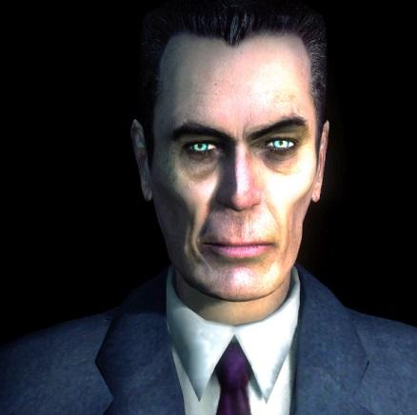

‘G-Man’ is a very eerie character, possessing very creepy qualities with the sombre, coldness in his voice and dialogue. He doesn’t say madly, threatening things to the protagonist of the game, yet he knows he doesn’t need to. The very presence of his self is enough to get the message across. Although hardly present within the game and barely seen, he still manages to maintain a lot of control over the atmosphere and the game’s story scenarios.

‘Hugo Strange’ from the ‘Batman’ series
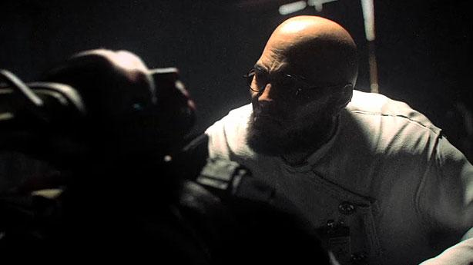
https://www.youtube.com/watch?v=muCtJsy-d9w

‘Hugo Strange’ also possesses the same coldness in his voice, when narrating and dominating through dialogue with one of the first trailers released for the 2011 ‘Batman Arkham City’. He knows more than anybody else in the story about our protagonist and he is willing to use cruel methods of interrogation and torture to find out more information. He is less physically endearing than the other characters within the game, yet he doesn’t need to be any more. The chemistry he has with Batman is deep enough to put only the two of them in the spotlight, and his coldness threatens to destroy the protagonist’s identity and road to enforcing justice.

What inspired my main artefacts?
I, Robot (Interrogation scene)
http://www.youtube.com/watch?v=05bGPiyM4jg
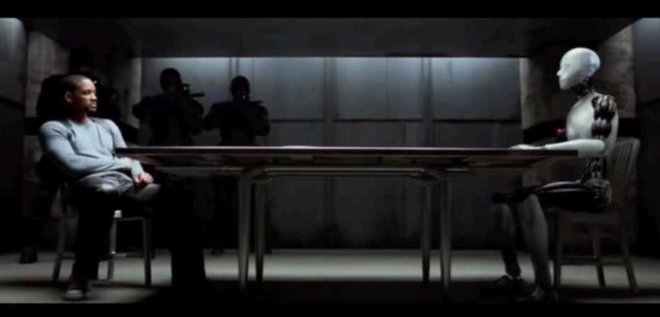
The reason why this posed quite a bit of an influence towards the concept of my main artefact, the official trailer, was because it took a very powerful and imposing character that is different to others and put him in a very vulnerable situation. He is threatening but fascinating and therefore a lot of attention is on him to where he needs to be studied. He is captured and subdued by a human but then afterwards manages to escape from their grasps and is on the run.
With ‘I, Robot’ they took this concept and made it very serious and dramatic, to the point where we could truly feel empathy for the non-human character because he is misunderstood and has had the image of a criminal forced down upon him. However with Clint, in contrast to Sonny of ‘I, Robot’, he is ironically easily understood to be an egotistical narcissist who forces the image of a villain down upon himself. Instead of trying to hide from the attention he is getting like Sonny was, he seeks it out even if the attention is not for the most fitting of causes towards him. To Clint the saying stands true that ‘bad publicity is good publicity’. With Sonny however publicity can be the reason for him being immobilised or not, and therefore the mood in the movie is much more serious to the mood in my trailer. And because of this, instead of a somewhat light-hearted and comedic interview taking place between the human and non-human, we instead see a very tense and serious interrogation scene taking place. The subject is not being found as ‘interesting’ or ‘remarkable’ to where he needs to be observed, he is instead being found dangerous and threatening to where he needs to be stopped. In my animation however I intend to take that key theme of a conflict and clashing of two of the work’s main characters, yet change the atmosphere.
With ‘I,Robot’ as influenced as I became with the product I was wanted to make sure I used these influences I found to create severe differences between Sonny's personality and Clint’s. Instead of shying away and being forced to withhold and suppress his emotions, I wanted to make sure that Clint was the very opposite and so would thrive at every opportunity to express his eccentric and wacky personality to the world, whether through his actions, his gestures or his words.

The Incredibles (Interview scene)
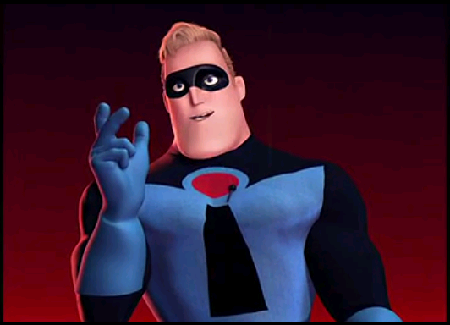
http://www.youtube.com/watch?v=YveIFphNcp4

This early scene within ‘The Incredibles’ was actually extremely influential towards me drafting up the main idea of my artefacts. Although the scene doesn’t actually feature the superheroes showing off their superpowers like it does with my super-being, it does however present them bragging about what they can do towards the audience. They reveal a lot about their personality within this short scene so early on in the movie and because they are at the top of their game within this era of the story their ego exemplifies their characteristics and charm. They are the superheroes of the city and they know everybody wants a piece of them, and to know more about them, because of how unique they are; and that’s how I made it appear for Clint.

Marker-less Facial Motion Capture Tech Demo
http://www.youtube.com/watch?v=3R2K5yXpWIM
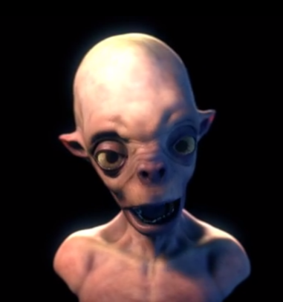
This animation is based upon facial motion capture, and is a brief talk with an alien. This inspired me to commit to my project as it awed me with the precision and quality that facial motion capture can bring, as it truly brought this fantastical life-form to life.
It also showed how all of the technical feats can combine together to create a rather comedic display as well.

Meet the Scout
https://www.youtube.com/watch?v=geNMz0J9TEQ
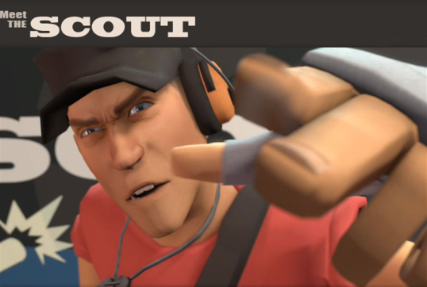
Within this trailer, it shows one of the playable characters of the ‘Team Fortress 2’ videogame in a much more closer and personal light. It is to the point where he actually controls the pacing and temperament of the trailer as he does mostly all of the talking, and his persona becomes very vivid and expression ate. He does something very interesting by actually addressing the audience, and breaking the 4th wall. He understands that he is being watched; therefore he brags and accentuates himself to perform. Valve’s trailer for their videogame succeeds well in presenting one of their many exaggerated and humorous characters for us to get to know, by having them actually speaking to us; raising the excitement and quality of the trailer tremendously.

Escape from planet Earth
https://www.youtube.com/watch?v=Q1NhAUsyslk
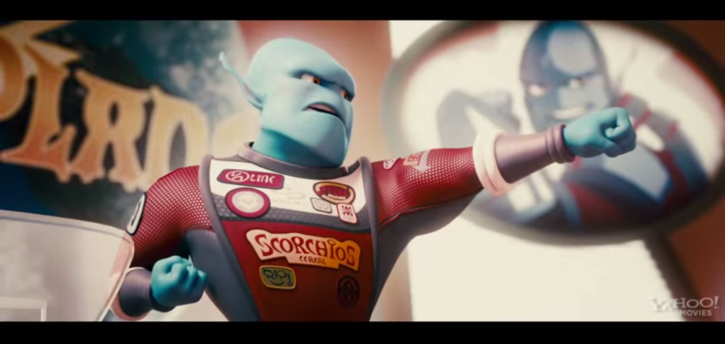

‘Escape from planet Earth’ is a recent movie which features a cast of aliens who have all been captured by humans within Area 51, and are now trying to find their way to escape and get back to their planet. They possess supernatural abilities and although comedic at nature, appear to be a massive threat to humanity. After already finding my idea I came across this production and decided it would prove worth studying to an extent as it feels very similar to the production I wish to move forward with. The aliens are very cocky and confident and possess highly charismatic qualities, all to which I want my own alien to carry as mentioned before.

Ratchet and Clank franchise

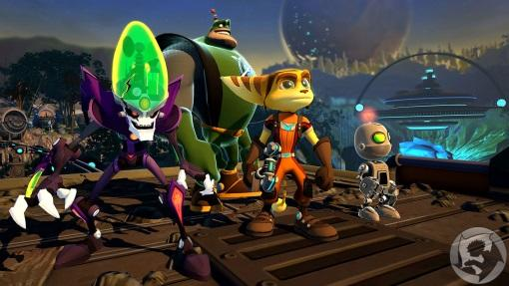
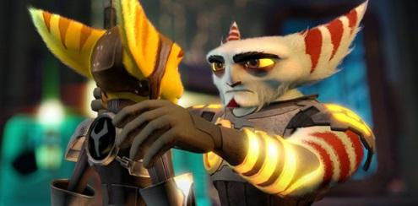
http://www.frontburnr.net/theblinkingopinion/wp-content/uploads/sites/12/2013/11/ratchet-and-clank-future-a-crack-in-time_screens_07-23-09.jpg
http://www.hardwareheaven.com/gamingreviewimages/ratchet-clank-all-4-one/ratchet-clank-all-4-one_screen1.jpg

The ‘Rachet and Clank’ franchise is widely recognized and vigorously loved by fans for its cartoon-like 3D graphics, and the incredibly vibrant colour palette within their games.
It does not go for hyperrealism, instead it concerns itself in presenting beautiful and artistic aesthetics which can still leave the audience with jaw-dropping reactions and appreciation to the visuals they are playing through. These type of graphics and bring in and attract a much wider audience, as the colours are very welcoming and connote warmer tones; making players excited to voyage the mysteries of the adventures they are about to quest through within the virtual, fantasy-world provided to them. That is what I also wish to achieve with the world Clint resides in as well.

Who inspired my main character?

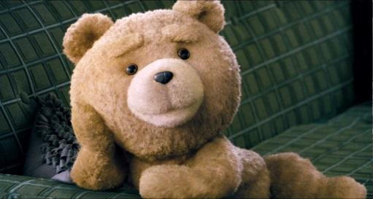
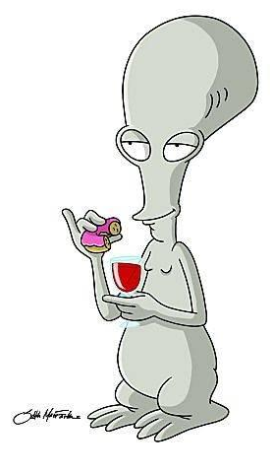
Roger (American Dad) and Ted (Ted)
Roger from Seth Macfarlane’s show ‘American Dad’ was perhaps the most influential existing character to inspire the concept and idea of Clint. Roger is an alien who lives with the Smith family, when Stan Smith had rescued him from capture by the CIA; and Ted is a teddy-bear from Seth Macfarlane’s movie ‘Ted’ who comes to life and spends the rest of it with his human owner and best friend.
They are both very narcissistic and self-absorbed, and make sure they always put themselves above everyone else; ensuring everybody knows this as well. They possess very strong levels of dark humour, and they lack many qualities that would suggest to the rest of society that they are indeed good people. They’re deficient of ethical remorse and often break boundaries again and again that turn them from one of the show’s protagonists into antagonists in an instant. However because of this there are so many layers to their characters and that’s what makes them a true joy and pleasure to watch. The audience have no idea what to expect from them and what actions they’ll take, we just know that it will be entertaining. All in all they are morally bad people that we would all hate to meet, but love to watch. And that is exactly the type of vibe I was aiming to have Clint flourish upon as he sets himself on the screen. Clint, as well as Roger and Ted, is narcissistic and self-absorbed to the point where he craves attention and doesn’t mind where or how he can get it; just as they are.

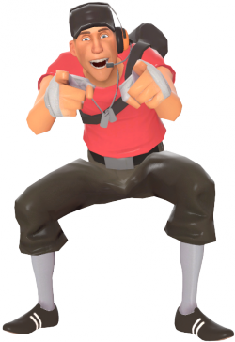
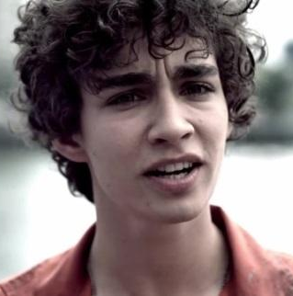
The Scout (Team Fortress 2) and Nathan (Misfits)
The Scout is a character in the ‘Team Fortress 2’ multiplayer game that you can choose to play with, and Nathan is from the hit television show ‘Misfits’ about a group of delinquents who are forced into doing community service but find superpowers in the midst of this.
They are both very cocky and arrogant, and believe themselves to be the best from the others therefore all eyes should be on them. They are immature and very young at heart. And for this you can forgive them, because they are very much the ‘kids’ of the bunch. Their cocky charm though annoying, also keeps them entertaining and actually catapults them at the top of every fan’s top favourite list. Their boastful allure forms magnetism amongst fans and potential fans, therefore I knew it would work towards Clint as well for my project. They are indulging and somewhat rousing towards the young male audience of viewers and players, as they possess an imaginary sense of alpha-male dominance amongst their peers and others that we as young men tend to do often; which I need Clint to possess as well. With this I have learnt there is a sudden attraction towards these types of characters, and that is the same audience I want to appeal to for towards my product.

Paul (Paul)

Paul was also one of my greatest influences towards inspiring me to create the character Clint, as he as well is a charming, mysterious and very funny to watch on the screen. Before creating my character I tasked myself with watching this movie as I knew I could learn a lot about the character I wish to create from the one I would be watching. There were many traits that I wished to integrate from Paul towards Clint, however when watching the movie I discovered that I needed to take these traits and exemplify them to an exaggerated extent. Paul has a great sense of character however his character did not stray far from the path of good and sense. He still in my opinion had many traits of a paragon. With Clint I wished to create a character with many layers to him that he doesn’t even seem like a good character and it may even feel as if we’ve been following the antagonist all along, yet we still cannot help but love him. I needed to take the good and loveable Paul and amp him up drastically, altering his sense of morality and ethics and transforming him into my not-so-good alien Clint.

Felonius Gru (Despicable Me)
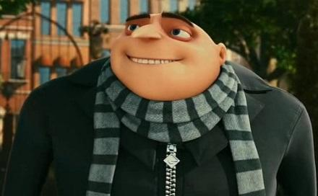
Felonius Gru is a very big-headed and arrogant super-villain turned hero of the movie, ‘Despicable Me’. Apart from being big-headed there were not many other traits I wished to proceed with for Clint. However what did catch on to me the most was Felonius’ noticeable yearning for attention, and being at the spotlight. Before officially turning to the good side he would always long for his biggest and wackiest schemes to be at the centre of the limelight. And he would take no satisfaction in not being known as the most evil super-villain there was. With this I knew I needed Clint to possess the same qualities, with an overly enlarged ego corrupting his priorities to making sure all of the publicity is on him even if it is limiting his well-being. By this I am referring to Clint’s cooperation with the scientist/ interrogator when captured, as it he believed it would bring him fame.

MOODBOARD

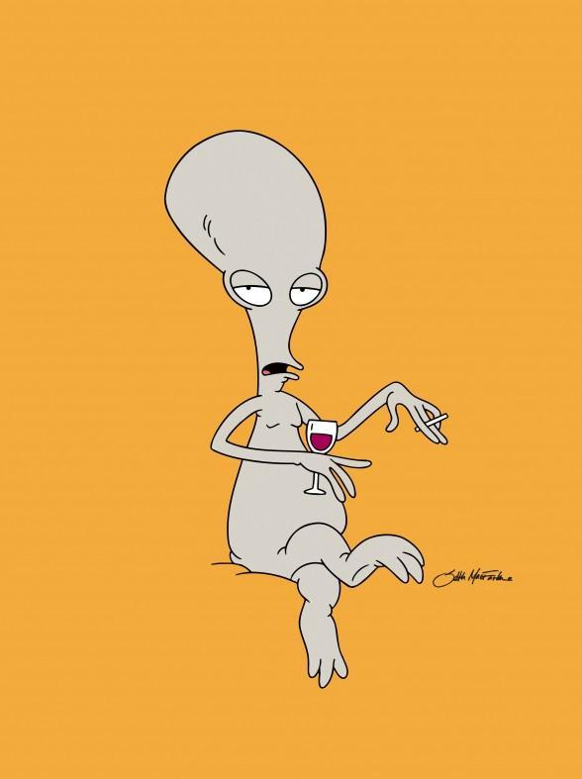
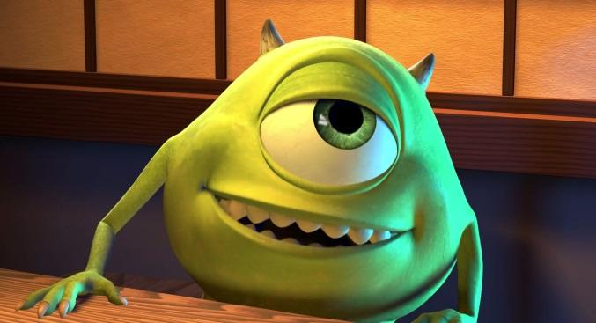

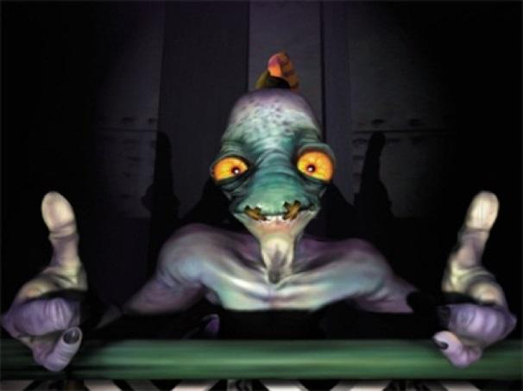
Body and Facial Language

Interrogation and interview scenes are highly confrontational, either from the interviewer’s behalf or the interviewee; or from both.
However just because interviews are very upfront; feelings and thoughts are often hid to protect oneself from exposing their true temperament on issues brought forth. Or on the other hand, they are overly expressed to further reinstate their feelings on certain factors by the words they have already spoken.
There are many physical signs that could present just how one is feeling in a situation like this, and due to this situation being the basis behind most of my artefact I believed it was worth looking into and researching to get a clearer ideology upon the notions.
Here are examples of body and facial language poses which all include their supposed hidden meaning, allowing exemplification towards the moods within the scene with their propelling of their own bodies in the shot. Most will be included within my storyboard and then onto my main artefact.
The examples are taken from the book, ‘What Every Body is saying’ by former F.B.I agent Joe Navarro, and P.H.D awarded Marvin Karlins.

FIG 43 – “Interlaced hands behind the head are indicative of comfort and dominance. Usually the senior person at a meeting will pose or “hood” this way.”
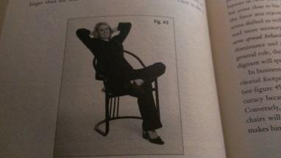
However I will have Clint posing in this dominant manner, to further clarify upon his overconfident mind-set and how as a captive he still believes he is on top, and ‘running the show’.

FIG 44 – “Fingertips planted spread apart on a surface are a significant territorial display of confidence and authority”
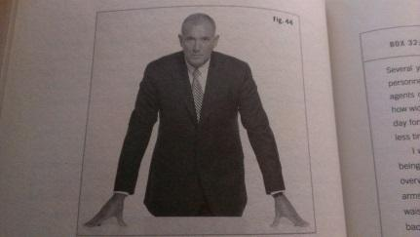
Clint almost always needs to feel as if he is in control within the scene, even if he is not. So with his fingers extended or even fists covering the table, it shows the extent of regulation and government he has.

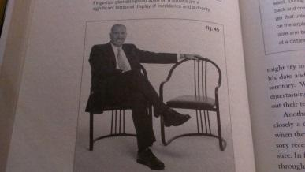
FIG 45 – “Arms spread out over the chairs tell the world you are feeling confident and comfortable.”
Clint is the kind of character to always feel as if he is in his own zone, which is part of the charisma that follows him. So he feels the need to sit back and relax, even if a normal character wouldn’t. He lacks the common sense at times to do otherwise.

FIG 46 – “Perhaps one of the most offensive gestures we possess is finger pointing. It has negative connotations around the globe.”
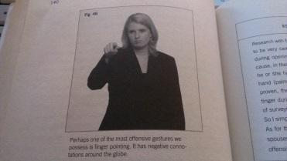
Clint is either too arrogant or uncaring to understand the offense in the gesture. He is overly expression-ate and flamboyant, and he is selfish. He doesn’t care how the other person will react to this which may serve for repercussions towards him, as long as he can get his own point across.

FIG 49 – “Steepling of hands, fingertip to fingertip, is one of the most powerful displays of confidence we possess.”
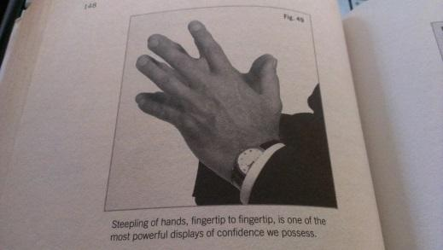
“When an individual is excited, he or she forgets to monitor and control the reaction”. Steepling is a powerful pose that I would want Clint to display, as he always believes he is in control of the situation and is excited to show off his abilities to the world he believes he stands atop of.

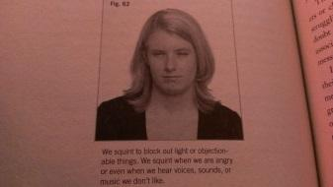
FIG 62 – “We squint to block out light or objectionable things. We squint when we are angry or even when we hear voices, sounds, or music we don’t like.”
Squinting would be effective for Clint to show his disapproval in much of what the interrogator has to say.
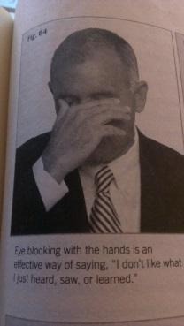
FIG 64 – “Eye blocking with the hands is an effective way of saying, “I don’t like what I just heard, saw, or learned.”
Clint may make such actions when he has become frustrated or even deeply saddened when he learns his abilities don’t work as he thought they would.

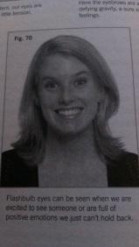
FIG 70 – “Flashbulb eyes can be seen when we are excited to see someone or are full of positive emotions we just can’t hold back”
Clint will take pleasure in the idea of showing off to the world and bragging about his powers, or may take joyous solace in the idea of redeeming himself when failing. This will be one way in which he may show it.
FIG 71 – “We look askance at people when we are distrustful or unconvinced, as in this photo.”
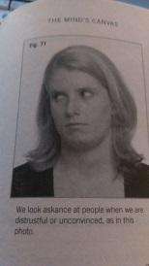
Clint may be silly, yet he will still have his moments when he doesn’t want to cooperate with the interrogator.

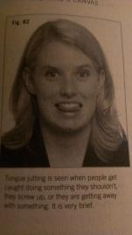
FIG 82 – “Tongue jutting is seen when people get caught doing something they shouldn’t, they screw up, or they are getting away with something. It is very brief.”
Clint is extremely cheeky, so this is a way he will show it.

FIG 35 – “Splaying out is a territorial display which is OK in your own home but not in the work place, especially during a job interview.”
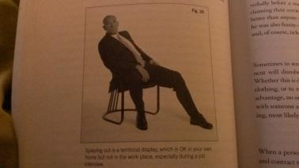
Clint believes he owns the place, though captive he thinks the whole scene is his territory and belongs to him. This is just another subtle way in which he might show it.

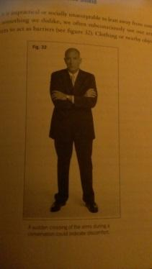
FIG 32 – “A sudden crossing of the arms during a conversation could indicate discomfort.”
Clint being as expression-ate as he will be will not hesitate in the slightest to show it, even if it is of bitterness. He will cross his arms when he is not satisfied at what he is hearing or observing without a flinch.

Technical Research
Software and Hardware I will be potentially using


3DS Max
I will definitely be using 3DS Max for my main pieces within my dissertation, being my 3D rendered animations. I already have a solid amount of knowledge and experience in using the software, and therefore I know I will be able to use it to contribute towards my designs and work very effectively.
3DS Max is specifically designed for building architectural spaces within a 3D scene. And due to me needing to create several spaces for different scenes within my animations it appears 3DS Max would be well equipped for getting it done and developing these. The scenes in my artefacts will vary from a small part of a plain desert, a white corridor within a lab, an interview room and the garden of a house. All of these scenes require a lot of modelling that can be advanced through basic to complex geometric shapes, which will then go on to be textured and lit up through the scene. And 3DS Max is perfect for being tasked with this. The program will also allow me to supply and direct cameras throughout my scenes when animating, providing for some very dynamic and exciting shots that can be executed to go alongside the motion and action of the story.
3DS Max has also proved to be more useful than just providing shapes to manipulate and transform to figures. It also has several features such as particle flow systems, which contain a huge amount of possibilities for the users to create with. Particle flow systems are are used to can be used to imitate actual environmental effects and configurations that we see from time to time in real life. It could range from such of a mountain within a green land, or more suitably for me sand on the earth in my desert scene, to even dust and frost emitting from a substance. 3DS Max also offers Bipeds as a system for us as the user to rig our own character with it and have them connected, giving our computer generated life-like creations a skeleton to move with. For these elements I will need to utilise the program and learn much more about it as well.
http://www.autodesk.com/products/autodesk-3ds-max/overview

Mudbox / Zbrush
In collaboration to 3DS Max’s ability to create and render architecture really well, Zbrush/Mudbox is a program of great potential for me to use to go forth and create and sculpt actual characters from. So when building the anatomy of my alien Zbrush/Mudbox has many assets for me to choose from to make it happen. Unlike 3DS Max, Zbrush/Mudbox is more of sculpting software which is exactly why it proves to be more useful and more utilised for character development within videogames and movies. So ideally creating 3D rendered characters such as the ones within the ‘Team Fortress’ games and the alien within ‘Paul’ would definitely have needed a program such as Zbrush/Mudbox, or even Maya and Mudbox to effectively sculpt a realistic or dynamic looking being.
http://pixologic.com/zbrush/features/overview/
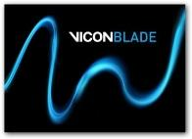
Blade
‘Blade’ is the software I will be using to composite my motion-capture works through so this is where it will be viewed, fixed up and collected from. This program is very effective because
http://www.vicon.com/Software/Blade



Adobe Motion Builder
This program will be used in alongside Blade and 3DS Max in order to clean up the motion capture animation that I will be using by ensuring that my character’s body does not move out of proportion of my own body’s motion capture. Although my own and Clint’s bodies will be possess very different structures physically, Motion Builder will allow me to guarantee that the animations I perform will still be able to be reflected fluently by my alien in a flawless manner. This program will entail that the differences from the physical structures of our bodies will not disrupt a seamless composition through our mirrored animation.

Nuke
This program may be used to composite the rendered video footage that has been compiled within 3DS Max and will be used to touch up the movie, polishing up the visuals of the work to help it become one big step closer to finalisation.
With this program we’re working around and with the video channels of the file to improve the effects of the videos and perhaps even fix or change some slight mistakes. With this program background colours can be changed on a whole, glow and shadows can be altered, motion blur can be commenced through the movement of the figures on the screen and on a whole it transforms the video into a more complete production that appears carefully edited and refined.
http://www.thefoundry.co.uk/products/nuke-product-family/nuke/features/

Adobe After-Effects
With After Effects, like Nuke, I will potentially be able to use this program as a post-production tool in order to polish up the animation, such as adding special effects with this program if I can’t figure out how to do so with 3DS Max. However from what I’ve learnt by using these two programs is that they do indeed possess strong similarities with one another; however Nuke is more node-based and After Effects is more layer-based. Regardless of that it still basically means to a general extent that whatever I can get done in one I can most likely get done in the other. So in that case instead of moving through both of the software back and forth at the same time, I will most likely stick with one just to get a smoother and quicker workflow going and to become more comfortable with the specific program I’m working with. However if I decide to create Motion Graphics within my animation, then After Effects will definitely be the better option to go with for that segment as Nuke is not well adept for it.

Adobe Premiere Pro
Due to being very familiar with Adobe Premiere Pro I have chosen this as the program that I will be using to create a demo of the menu interface with. I have created a demo of a menu interface before with Adobe Premiere Pro and it came out to a very impressive standard, so I believe it will benefit me far greater to stick with what I know. I’m excited to be taking another shot at it for this project in the hopes that it will only be more of a success than my last.

Adobe Illustrator

Adobe Illustrator will be an immensely necessary program that I will need to utilise and make the most out of to assist with the main pieces of work I will be producing. Illustrator won’t necessarily need to be used for the animated segments of my work; however tasks such as creating a logo and 2D still designs will need me to take full advantage of the program. Illustrator will be tremendously efficient to create nice, shaded vector designs which will be really fitting towards a game which is completely dedicated towards being fun, free, and humorous; and not to be taken seriously. The art style within the 2D graphics as well as the 3D graphics needs to emit a sense of fun in order to go with the themes of nonsensical humour and ludicrousness that will be present throughout the works to fit with the spirit of the character’s charm and charisma


Adobe Photoshop
Photoshop will be useful for many areas amidst the design elements of my campaign as I will use the program to influence a huge portion of the aesthetics of my main artefacts, being the animations. For these I will be able to create realistic looking and dynamic textures to apply towards the models. I will also be able to use the program to design the layout and looks of my menu interface that will be used for the game, and also the use it to produce a various amount of ideas for the print and digital design work of the campaign such as posters and wallpapers.


Logic Pro
‘Logic’ is a sound editing software that can be used to create music and sound tracks; which I will be doing to a small extent and then compiling it towards the rest of my work to assist with it and the build upon the quality and finalisation of my work. I will mainly be using Logic to create a very short musical intro and outro towards the animations I will be creating, so it will therefore be known as a trademark to the game; just as every television program has a musical jingle of sorts that is representative and emblematic of the show.
I will also be using Logic Pro to assist in forming a few of the several sound effects I will be needing to implement and integrate towards the animations I will be creating, which will help to provide a more authentic feeling to my major artefact pieces.
https://www.apple.com/uk/logic-pro/what-is/

Zoom Sound Recorder / Sound Recording Studio

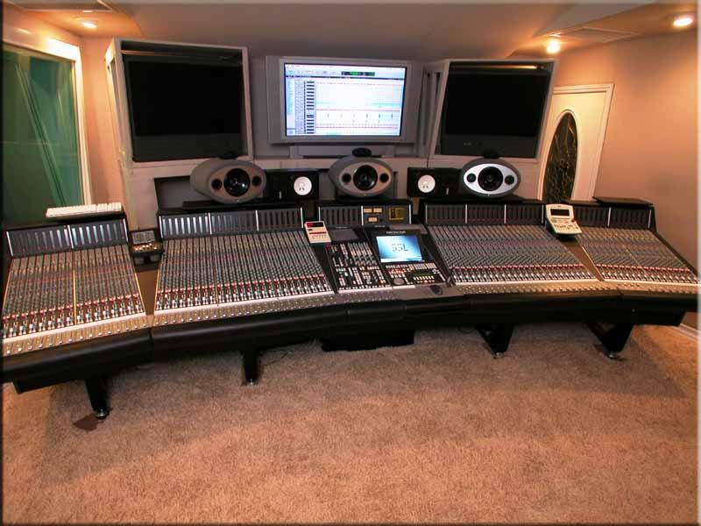

I will be using a sound recorder and the sound recording studio within Brunel University in order to record the voice acting needed for both of the characters present and featuring within the animation. Hardware offered by these devices will enable me to record clear speaking with little distortion appearing within the sound, so that the quality is good and fitting for the animation.

Rigging, Skinning and Weighting
Rigging - The skeletal basis that the mesh will apply itself upon. Bipeds are basically human-like skeletons that to be applied inside of models to allow them to be animated. You can also get quadrupeds for four-legged creatures, and much other type of CAT rigs to be implemented towards your character however I believe the biped would work best for me as I am mostly familiar with this and understand how to modify it specifically for any type of two-legged character. So due to prior knowledge and experience that I have with the system I will choose to use this
Skinning – This involves connecting the skeletal parts towards the body parts among the mesh. This ensures that each part of the model's anatomy is covering a joint of the biped and being controlled by such. Skinning is useful as it can also further allow me to create new editions to the skeletal data and add more bones to the mesh, to control different parts of this. I will need to examine this further when it comes to the facial rig, to understand if it works well and is possible for my alien.
Weighting - This allows the necessary constraints to be applied for the movement of the mesh based on the animation of the rig, making sure that the body moves realistically and accordingly to how you want it to. This part concerns itself with how the several parts of the body that affects one another and itself when moved. To emphasize upon, my model although seated will needed to move very freely and in an exaggerated manner because of his ‘toon-like’ features and characterizations. Therefore weighting needs to be precise and well-done so that noticeable distortions will have no chance of occurring.

Motion Capture & Facial Motion Capture

Humour within a work can only truly work with the audience are completely engulfed within the story, and immersed within the atmosphere to enjoy it. There are several means to find ways to achieve this, whether it be through the story or the motion of the characters; however usually a combination of both. In order for me to achieve this I decided to use performance capture technology in order to bring my character to life in a humorous fashion by replicating a lifelike form. Motion Capture of all kinds have been around for quite a few years now, often being used in movies, videogames and other forms of visual interaction when a computer-generated character is needed. For my animation I decided to go down the route of learning to utilise Facial Motion Capture and Full Body Motion Capture, therefore I had to do a lot of studying into these processes. To use this I would initially have had to record my face and body (or another’s) as a reference for my alien, then have the recording of the face and body projected onto the CG character.
The way that facial motion capture works is that it to processes information on a person’s face in order to calibrate the shape of it to form the architecture of it digitally. By then it can read the movement on the face electronically and convert it forward onto a digital database. This is done and actually captured using digital cameras and/ or lasers as an input device. In order for the computer to easily understand what expressions the face is trying to make, co-ordinates are plotted on the face in the form of small physical markers for the cameras/lasers to track the movement of the muscles on the face. Or if marker-less, then the computer will use more blunt and obvious features in the face such as the nostrils, the corners of the lips and eyes and wrinkles; and follow the movement of these to form the composition of the face and record it’s tracings. As an output the recorded movement will then be processed and computer generated onto a model of your choosing that is within the database as well.
This would be a great idea, as there are a huge amount of advantages to using facial motion capture to animate faces. It would be efficient to portray expressions realistically as the computer is automatically capturing and processing the movement of the reference’s face accurately. It would save plenty of time because the computer is doing all of the work, instead of a human manually having to do it and making mistakes naturally. Therefore there is more time for us to focus on other sections of animating and perhaps even put in much more time into the modelling and texturing of the character, as most of the animation will be done for us apart from the cleaning up of it.
Full Body Motion Capture also works in pretty much the same way; however it is generated over an entire body instead of just a face. This sounds harder when referred to like this; however it is generally much easier than Facial Motion Capture to perform and have emulated. And though there are many pros of Facial Motion Capture, there are also several cons in trying to use the process, in comparison to its full body counterpart. The biggest downside of them all is the accessibility of the software and hardware since they are very limited to us, especially as students. The equipment and software to work with are external to Brunel University, meaning I’d have to find it elsewhere. And it can be very expensive, costing well above thousands of pounds for a few sessions. This would be very risky for me as I’d need a few sessions alone to get an understanding of the software and hardware, and then more sessions to actually get the work done. The process of producing the motion capture as well is not simple, as it relies on high resolution requirements to detect and track the subtle expressions formed from even the smallest of muscles within the face. Forehead lines and eyebrows rising from a smile for instance are very difficult for the cameras/lasers to detect. Small movements of the lips, eyes or nose if they were supposed to be twitching or moving faintly or so would also require a lot of scrutinising manually through the computer as a lot of accuracy is needed.
Due to the movements within the face being so sharp but miniscule, often being performed in a scale of less than a few millimetres, even greater resolution and fidelity is needed to capture them compared to full body motion capture. So much more focus is involved to read and render realistic movement, compared to the more flamboyant movements that can be performed with the full body. Therefore if you want to have a computer-generated face moving realistically and accurately according to a recording of a referenced face, it requires much more work than if you were doing so with the rest of the body.

Why use Motion Capture to begin with?
On top of understanding how motion capture works, I also had to see if it was applicable towards the type of animation I wished to produce as well. Although motion capture has been becoming a very dominant method of implementing movement within CG and animated movies, there are still a number of reasons why it is avoided, even in big productions. Motion Capture can be very tedious in the whole run of things as there are so many steps when it comes to using it. There is setting up which involves creating booting up the system, calibrating the system to enable the many cameras to be capable of actually interpreting movement within the scene, applying the markers specifically on the actor’s body, capturing the take, and then cleaning up the take afterwards. Of course after that we still need to apply it onto our characters which can bring a whole other chain of problems to occur. However these frustrations may not even act as the main decider for not going with motion capture. The biggest worry can often be whether or not the data-read animation will actually suit the character, in terms of behaviour, biology and realism or non-realism. If the character is short, difficulties can occur if the actor reflecting the character is really tall; as the anatomy is extremely off. If the actor is rather slim or even frail, then portraying a heavily bulky and muscular character can come with a huge amount of hindrances as well; as clipping can occur due to the range of motions being entirely different.
As mentioned by:
http://3dworkshop4u.blogspot.co.uk/2011/11/motion-builder-tutorial.html
“If the computer model has different proportions from the capture subject, artefacts may occur. For example, if a cartoon character has large, over-sized hands, these may intersect the character's body if the human performer is not careful with their physical motion”.
Proportions have to be seriously considered in order to execute a flawless motion captured performance. And if required that the character needs to be highly animated and exaggerated in performance, then motion capture can prove to be a difficult process to abide by as we as human performers have various conscriptions that will not allow us to achieve such results.
Also said, “Movement that does not follow the laws of physics generally cannot be captured.”

Key Frame Animation is still often used today, and has been used effectively in a wide array of massive animation productions. Pixar have used this method, instead of motion capture, in all of their films and are well renowned for their abilities in animation to have never needed to boast the use or need of motion capture. Reasons to why they and many other animating studios tend not to use motion capture is because they believe it would actually affect the quality of the animation, and the movement of the characters.
Scott Clark of Disney believes “Motion capture, the tracking of movements from cameras placed on actors, would not be helpful to animation. Clark believes that it would still just be a person in a suit acting like a character, instead of the character itself performing the motions.”
http://pixartimes.com/2013/06/12/seven-things-i-learned-about-animation-from-monsters-university-supervising-animator-scott-clark/
Many artists and studios also believe it rids themselves of the actual prosperous and hardworking aspects of animating, withdrawing the feelings of achievement once performed. Pixar Portal builds upon this argument stating;
“It doesn't really conform to the traditional definition of animation. It's really less computer animation than it is computer stylization. I do not mean to minimize the hard work of motion capture technicians. But the hard truth is, with the exception of some tweaking, performance capture replaces the animator with the actor. And the actors are feeling overlooked for their captured performances too. We need new Oscar categories.
Definition disputes aside, motion capture have yet to truly gain the affection of audiences. You'll hear people use words like "creepy" and "lifeless" to describe performance capture characters. Pixar has been proudly opposed to motion capture techniques, even going so far as to badge many of their films with an icon in the credits that reads: "100% Genuine ANIMATION! No motion capture or any other performance shortcuts were used in the production of this film."
Rather than boosting the excellence and value of the animation motion capture is often actually seen as a hindrance, detracting the audience from what should feel real to the story’s world and people. With the theory of inner logic, it can be argued that characters moving ‘toon-like’ and in a conventionally unrealistic way, actually seems normal for the audience to view because it appears to fit them so well. They are fantastical characters and therefore should appear and move as such, if they were to move like actual human beings of our world, then it would look off as the movement wouldn’t match their character. John Lasseter says;
“Animating very cartoony motion with lots of squash and stretch on a realistic looking object may not look believable, as would realistic motion on a caricatured object. This is the pitfall of using motion capture devices to create final animation.”
Pixar Portal continues to discuss this exclaiming that;
“Lasseter is talking about the infamous ‘Uncanny Valley’, a proven phenomenon which turns people completely off to realistic characters because your brain knows that something isn't quite right. Animation has always been about exaggeration. We invented the camera to emulate reality.”
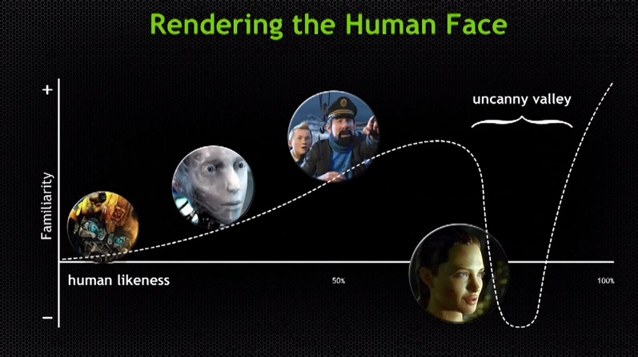
When it comes to animation we can gain a feeling of what we’re familiar with, and what we find realistic, or both combined. Only when we combine both is when we have an artefact that feels uncanny and almost seamless between the animated world and our real world. Realism overdone can feel odd to the screen to see because we are looking at a subject that should actually be real, and therefore it feels as if we are no longer watching an animation in the works but a real life production. However this is extremely difficult to pull off well because the life-like motion needs to match life-like graphics, or else it will feel non-fitting. With the diagram above ‘Forbes’ are arguing that Angelina Jolie’s portrayed animated character reached Uncanny Valley within ‘Beowulf’ as we as an audience are not familiar with watching an animation that seems so life-like, yet clearly computer generated either because the graphics do not consistently feel 100% real, or the world doesn’t feel 100% real. When realism is done so well that it is near life-like, any form of ‘roboticness’ can be seen clearly. It is easy to find flaws with something that is nearly perfect but not quite, as usually they are the only flaws one is searching for. Forbes mention;
“The core of the hypothesis states that as robots become more human-like in appearance, our emotional response to them grows more positive. That is, until the robot appears just one shade shy of being human; at that point we experience a feeling of uncanniness and even revulsion.”
http://www.forbes.com/sites/jasonevangelho/2013/03/20/goodbye-uncanny-valley-nvidias-face-works-brings-shocking-realism-to-facial-animation/
In other words what was supposed to feel normal, realistic and natural; ends up feeling the complete opposite. It begins to feel like watching real life turn to animation, instead of animation turning to life. Hyperrealism is when art and animation feels and appears real, no matter how fantasy-like the world or concept is. So with 3D in instance, when the approach to realism is done well it can seem so real that what happens within it becomes almost completely accepted as actual and genuine. However if the work can not completely succeed with its attempts at executing hyper reality, then it can fall into the uncanny valley definition.
When characters on screen do not match their performers
There are several of issues when it comes to providing motion capture with actors off screen, towards the characters on screen. However although it can prove difficult and hard to implement, it can be done; and it has been done. that motion capture performed by actors with absolutely and completely different body types to their characters have been achieved successfully. Both Golem from ‘Lord of the Rings’ franchise, the ‘Na’vi’ race from the movie ‘Avatar’, and Caesar from the ‘Rise of the Planet of the Apes’ franchise are performed by motion capture artists who had to adapt to movements unlike their own real-life motions, and to a spectacular extent as well that they have both be nominated or won multiple awards. Making the characters become two of the most memorable in the history of animation.
To a further and even more irregular manner, characters of complete human deformity have been performed motion capture through; to a successful achievement as well.
Smaug is a character within the latest ‘Hobbit’ movie, and is actually in the physical embodiment of a dragon. However the advancement of motion capture technology has become so adept it allowed actor Benedict Cumberbatch to perform both motion capture for the face and body of the dragon to an impressive extent. However of course plenty of key framed animation would be involved, yet regardless the fact that it can be done at all for such an unorthodox and biologically different character is truly an amazing achievement in itself.
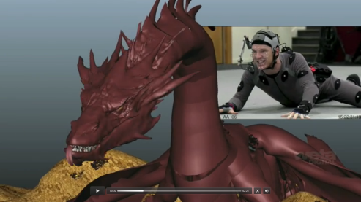
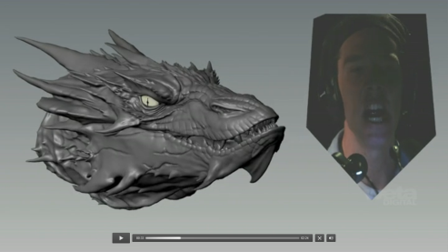
http://www.hollywoodreporter.com/behind-screen/benedict-cumberbatch-performs-mocap-smaug-682351
To perhaps an even more unorthodox manner, the character ‘Ted’ within the movie ‘Ted’ is completed animated by Seth Macfarlane,who also voices the character and created the character. Although a biped and not a quadruped such as ‘Smaug’, ‘Ted’s’ body is still completely different to his actors. Yet the movie was able to achieve a flawless execution of the transitions between both the performances of the actor to the motion of the character. It really brought the character to life without detracting the audience with the idea that the teddy bear was being controlled by a human. The inner logic just has it that he was supposed to move that way, a toy unlike the ones we see in Pixar’s ‘Toy Story’ movies, but more realistic. To use the motion capture to endorse comedy and create a character filled to his depths with hilarity required the audience to be capable of being fully immersed with his character, and that’s what the studio did.
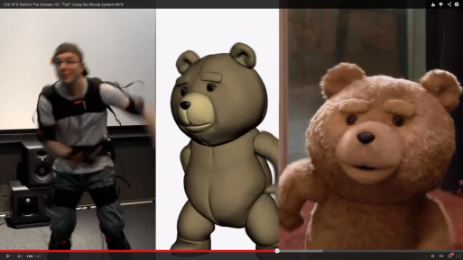
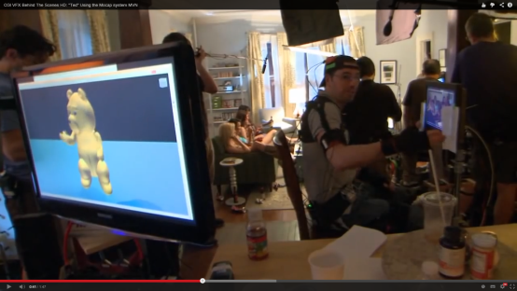
https://www.youtube.com/watch?v=hZhiwppXdJ8
It used to seem as if motion capture could only be done effectively with characters that biologically resemble the actor playing them. However evidently it has been proven again and again that the depths and realm of possibility with what motion capture can achieve can be expanded further, and explored to gain all kinds of results. This to where you could have never even guessed that an actor played the character to begin with. With this knowledge it reinforces my idea to use motion capture towards a more fantasy-like character, being my alien ‘Clint’, and presenting him in a life-like and ‘comedic-ally’ animated way yet not attempting to make him seem human. Of course the equipment that the studios behind all of the movies listed possess are much more technically advanced due to the high budgets and production cost they have, making what they are trying to achieve more possible. Yet I still do believe it is possible with me and the facilities I have as though my alien’s anatomy and body structure is different in comparison to mine, it is not extremely different to my own; making it to my belief achievable.
Even with my decision to go with Motion capture, I still understand the need for Key frame animation and how it will still definitely play a part within constructing my animation as well. Motion capture can capture human expression more accurately for you to see funnier displays of body language and towards a clearer extent. However there is only so much you can do with your own body to emit hilarious visuals to the point that you need to work manually by a computer yourself to alter the animation by hand.

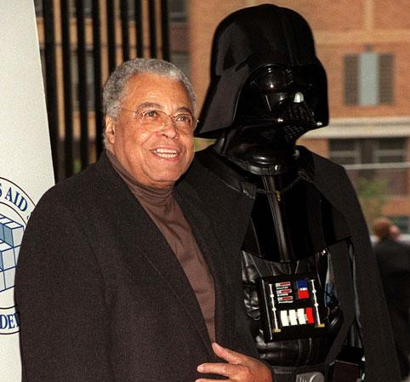
Voice acting
Voice actors need to depict their characters voices. This has been done extremely well by actors such as Robin Williams, as Genie within the movie ‘Aladdin’, and James Earl jones as Darth Vader from the ‘Star Wars’ franchise. Really and truly theoretically anybody can voice the character, but only few fit and hit the mark.
When it comes to finding the right voice actors for the particular role, a huge amount of consideration and trial and error is required. James Earl Jones wasn’t even meant to play Darth Vader at first; however the directors wanted a darker voice with more presence to capture the character of the villain. David Prowse performing as the antagonist was not enough for the studio, as although he could portray the motion of the villain; they did not believe he could portray the voice. For Darth Vader it may have been to be menacing, however this applies for whatever type of story it is and character it is for. Same goes for humorous characters
https://www.youtube.com/watch?v=RAJgnUix2kI

For Clint, he is not meant to appear threatening or even blatently dominant through appearance, therefore his sound needs to reflect this. He should sound comical, and harmless to make him more lovable by his audience and the players that would play with him if the adaptation was to be turned into a videogame. As mentioned, comedy brings about a much broader audience than many other genres; therefore the voice of Clint needs to emit comedy well.
http://www.speechbuddy.com/blog/wp-content/uploads/2012/08/James-Earl-Jones-with-Darth-Vader.jpg

DESIGN PROCESS
Concept Design Sketches analysis
Before moving straight onto the design process, I decided to do a bit of research onto what kind of methods and planning are partaken through to give designers and animators of the like a better idea onto how they want their final product to look like. I already have prior knowledge of certain development stages of such, however I still believed it would be vital to follow through with more research in order to gain further clarity upon the process.
This ‘webisode’ video of ‘Star Wars: Creating General Grievous’ from YouTube helped me gain some finer details on the matter.

http://www.youtube.com/watch?v=tBOoZ5Tuh2o#t=244
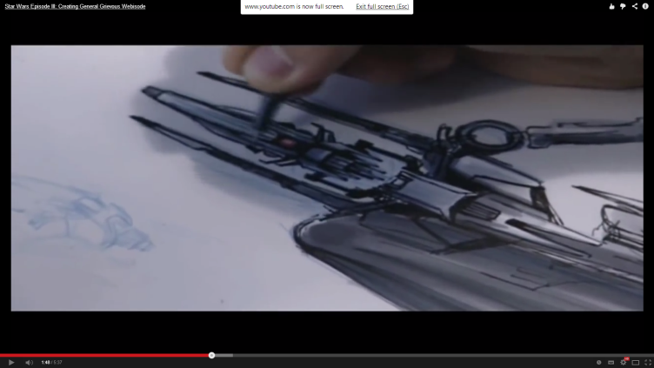

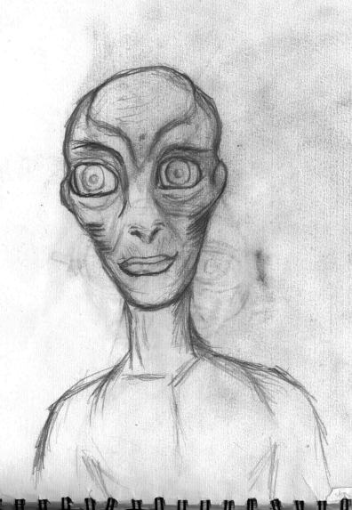
The Head
Sketch 1 – My first sketch is perhaps the most original of the bunch, however I believe it’s an idea that looks a bit far off from the personality Clint is supposed to portray. Clint is supposed to be a very cocky, egotistical and comical character, emitting a lot of energy due to all of the charisma he carries. But within the sketch here I personally saw a being that seems very innocent and shy. He appears to be a character that could be loveable but for completely different to what makes Clint shine. I need Clint to be reflect obvious appearances of cockiness and cheekiness, so for a videogame that is very much straight-forward about fun I need his looks to appear as such as well.
Another reason was that the character in the drawing was lacking a sense of something truly special and unique to separate himself from other alien designs. Although I do indeed like the character design, he doesn’t stand out much as a very innovative and imaginative design. His body is far too proportional and regular, almost posing for a boring design. So that was another thing I had to consider fixing for my next design.

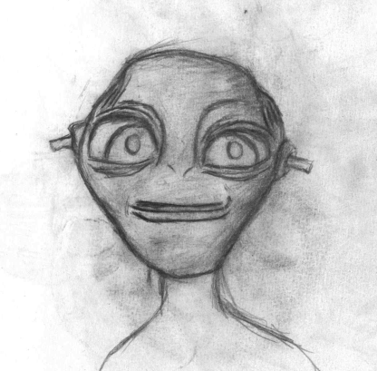
Sketch 2 – With this sketch I believe I successfully reflected a character that does indeed look cheeky, humorous and charming; however I do believe that he may still appear somewhat innocent because of how child-like he appears. It would be very difficult to imagine this being submerging a house down to the ground in a villainous manner; as his appearance seems far too cute for such devious actions. In my opinion he doesn’t appear as if he belongs in a videogame played by older teenagers and above, but more of a character in a game played by young children.

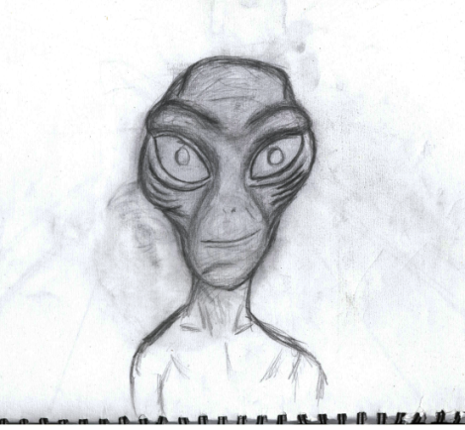
Sketch 3 – This rendition of an idea of how Clint could look happens to be amongst my favourites from all of the others. I believe I successfully created a design of a character that can live up to the personality that Clint depicts throughout the scripts within the animation.
Physically the design is very fitting for the character. He possesses a massive head on a small body, symbolic to his massive ego and how big-headed he is. His body is scrawny and petit, making him feel and appear less imposing and threatening than he actually is, giving him a sense of child-like innocence and increasing his lovability due to this. His massive eyes also give off a further notion of innocence, and his brow-structure on his face makes it more suggestive that he tends to pull a lot of expressions, in particular ones that raise or lower the eyebrows which in itself advocate a strong feeling of cheekiness upon him.

However when creating this design I took a great deal of influence from the character design of Paul, from the movie ‘Paul’, and I believe I strayed too far deep in inspiration into his appearance. Many of the physical features within my design are too similar towards the features possessed by Paul, therefore I believed another attempt needed to be taken so that my idea can be a more unique and original idea execution.
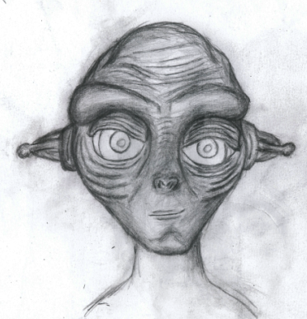
Sketch 4 – For my final sketch I decided to combine a lot of the features I liked from my previous designs together to form a final design that I would be content with.
For example the ears were mainly inspired from Sketch 2 but changed a bit, the eyes mainly from Sketch 1 though improved, the head and facial shape from Sketches 1 and 3 although altered and made more round. The mouth from Sketch 3, the facial bone structure and skin mainly from Sketch 3 but partly from Sketch 1 as well etc.
This became my ultimate design to take forward as it featured everything I needed my alien to portray. He looks unique, cool and original enough to be easily identified amongst several other alien designs; however he still manages to maintain a human look that makes him look less like a villainous monster, and more like a protagonist. His head is big compared to his body, symbolising the big-headed, arrogant, egotistical character I was looking to illustrate. And very importantly his facial structure though unique, is also very simple and symmetrical, hopefully making it somewhat easier for me to model, texture and animate.
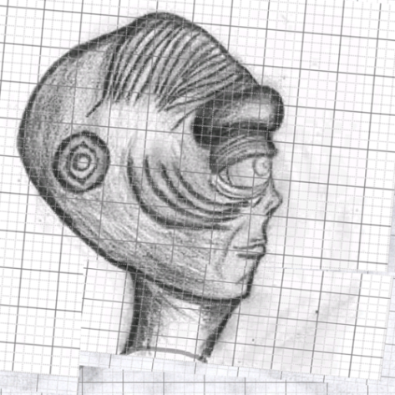
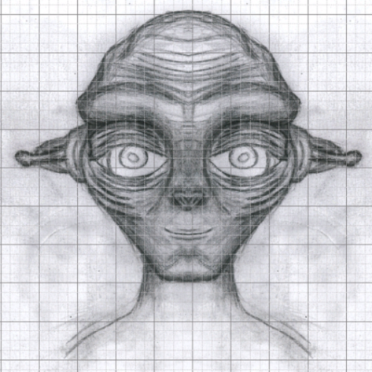

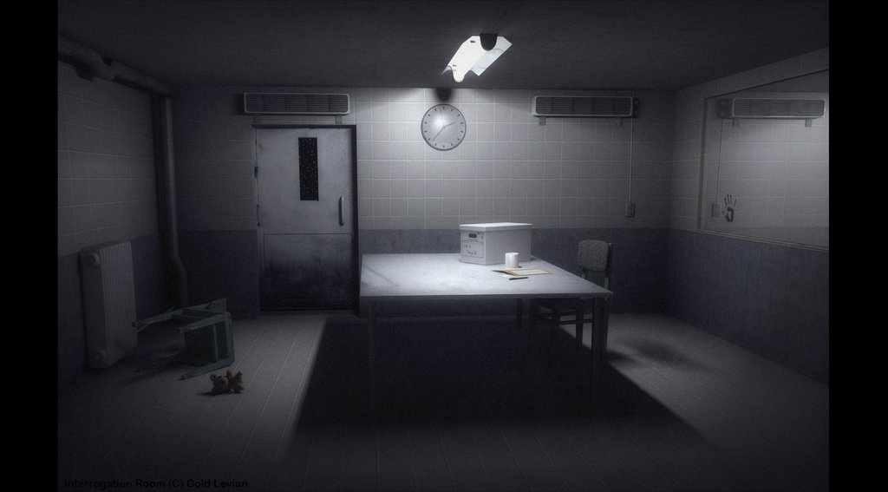
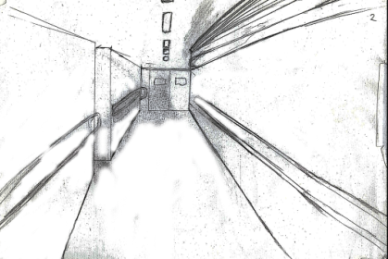
The Scene

These are a couple of examples of how I wished my scenes would look. They are based upon two of the main scenes that will definitely be appearing within the trailer.
The first image is based upon a rough sketch that I myself created for the scene. It needed to be very simple as it is a corridor that will be guiding our main character to his main scene, where he will be shown the most.
In the full production the corridor will be much dirtier and grittier, to further endorse the idea that Clint is indeed being held captive, even if the animation itself is not as dark and grim to suggest that.
The second image is a picture I came across within Google, of an interrogation scene and the setup of the room. It is also dark, and very simple and empty; which is important to remember when creating the scene as it exemplifies on how Clint has been captured. Therefore he has no luxuries with him, he is not in a place he has chosen to be in, he is within his antagonist’s depths.

The Body
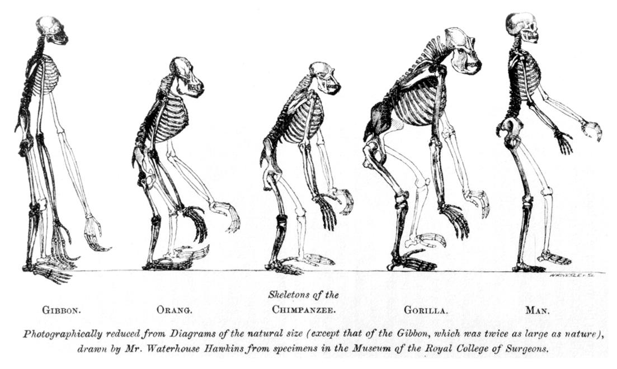
Apes are known to be highly intelligent creatures that relate to humans biologically the most, out of any other types of species or breed of animal. Stereotypically they’re also known to be cheeky creatures, understanding hilarity and often participating with the actions and senses of comedy in a huge array of displays of their interaction.
These were enough reasons to inspire and influence me upon strong factors towards my design of the alien, as I also want him to possess many of the characteristic traits that they own. Therefore it would also make sense for my alien to possess many of the physical traits that they own as well.
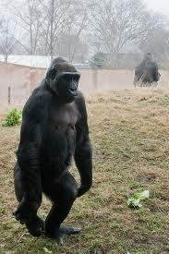

http://byt.wpengine.netdna-cdn.com/wp-content/uploads/2011/01/gorilla.jpg

The Storyboard
Here is the storyboard that I had conducted for the project.
To be noted, the full production may not feature every scene and may change in time straying away a bit from this storyboard. However this is where I gained the most of my ideas for the product so the overall theme and concept will be maintained, along with a few definitive scenes from the story.
Note: Please zoom into the pages to get a clearer view and reading of the storyboard pages.

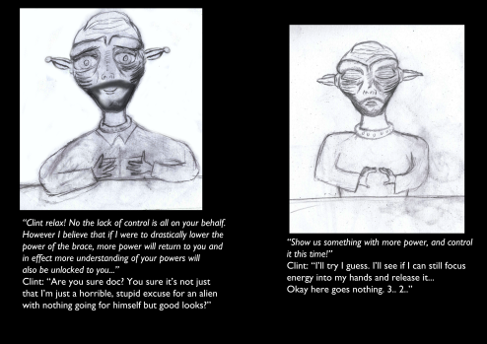
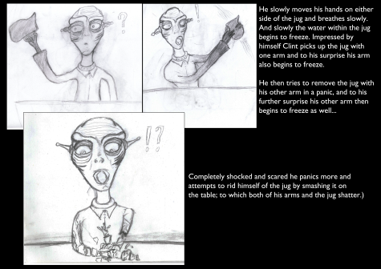
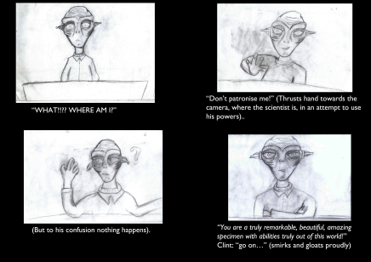
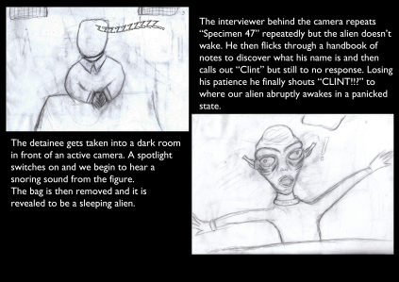
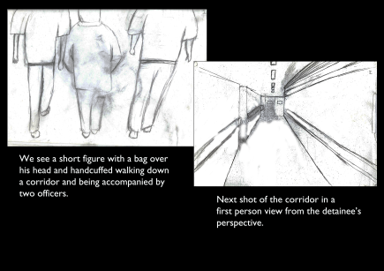
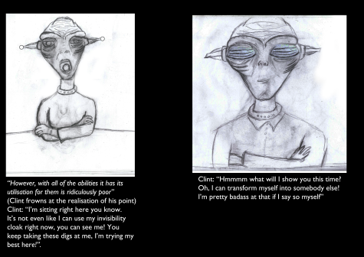
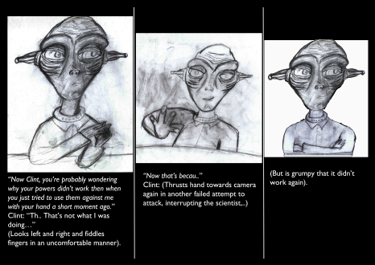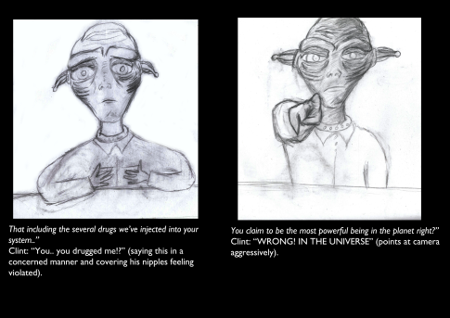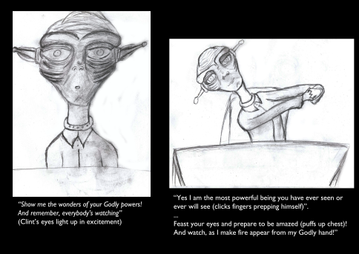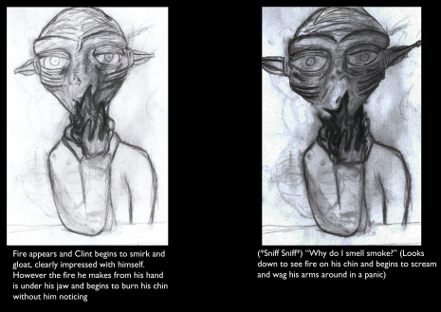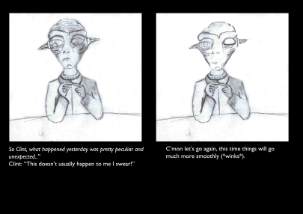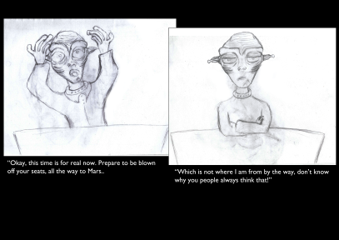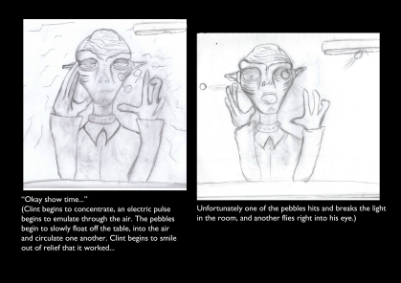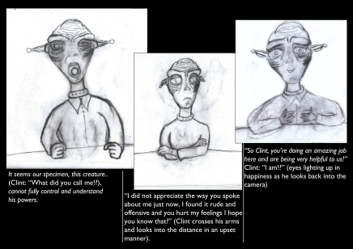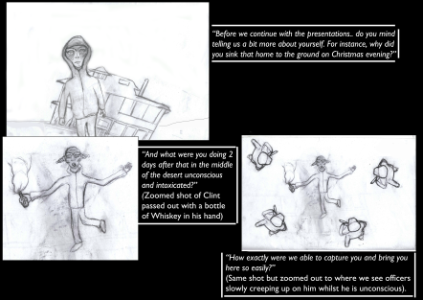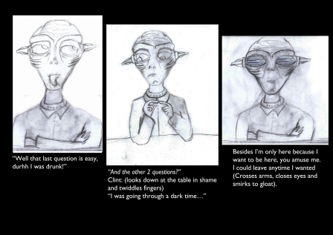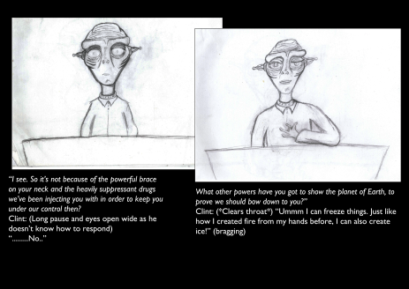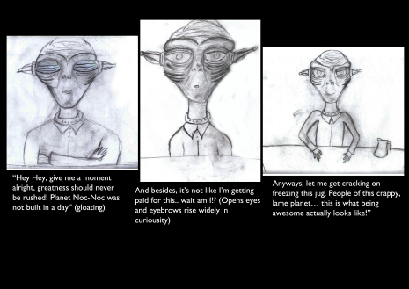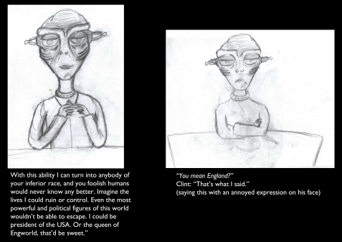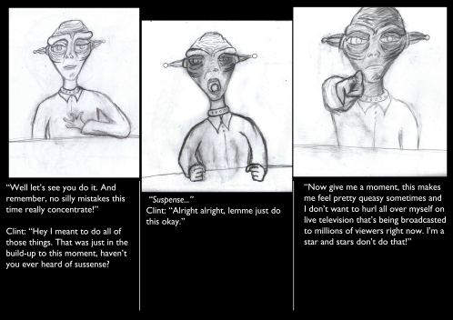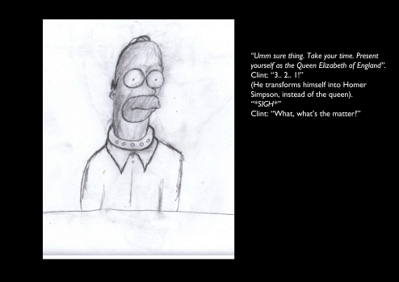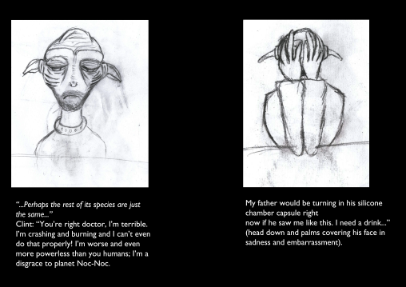

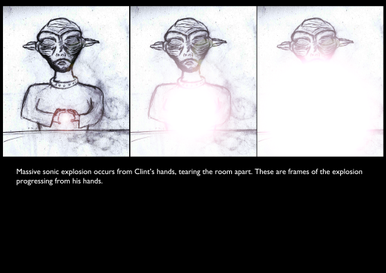
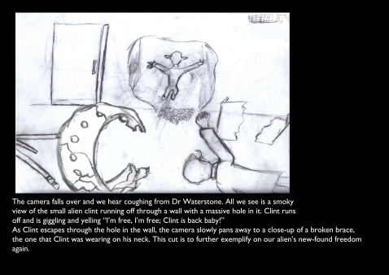

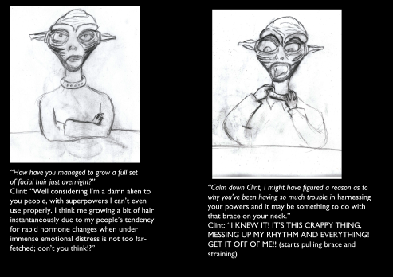
TESTS

Creating fire test with FumeFX

SitniSanti’s Afterworks’ FumeFX is a plugin for 3DS max I have had my eye upon since the beginning of my thoughts of creating the animation, since starting my research. I knew from the get-go that manually simulating fire without the plugin will take a huge amount of time and trial and error, and for a project like mine where I would have to create so many other features which are more important as well I would not have to time to focus on that. So FumeFX is a quicker alternative, and though still time-consuming and difficult to render, it would still prove to be the better of the two methods as the results are more guaranteed to work at a better extent.
It has been used in several big productions such as the 2011 movie ‘SuckerPunch’, and even as early as 2007’s ‘Spiderman 3 and 2006’s ‘Superman Returns’. It is well renowned within the VFX industry and looks to be increasing in users, ensuring a solid future within the industry.

Briefly explained, to make it work I had to create a sphere as a base and source of the fire, to direct the fire and have it understand where it needs to emit from. Then I could create the fire basis and create a container around of it, as FumeFX is render-heavy program and so 3DS Max should only work with rendering everything that’s in the box. The box/ container will grow in size as the fire grows, but it won’t abruptly spread, which would destroy rendering time and possibly even crash PCs of moderate power. Then we can actually create the entity of the fire (the scribbly sphere-like orange figure within the image below), and have the fire select the ball as the source, and then use the container to create properties for the flames whilst it remains within the container.
This test proved to be successful and to be moved onto the main implementation phase, to be discussed further on.
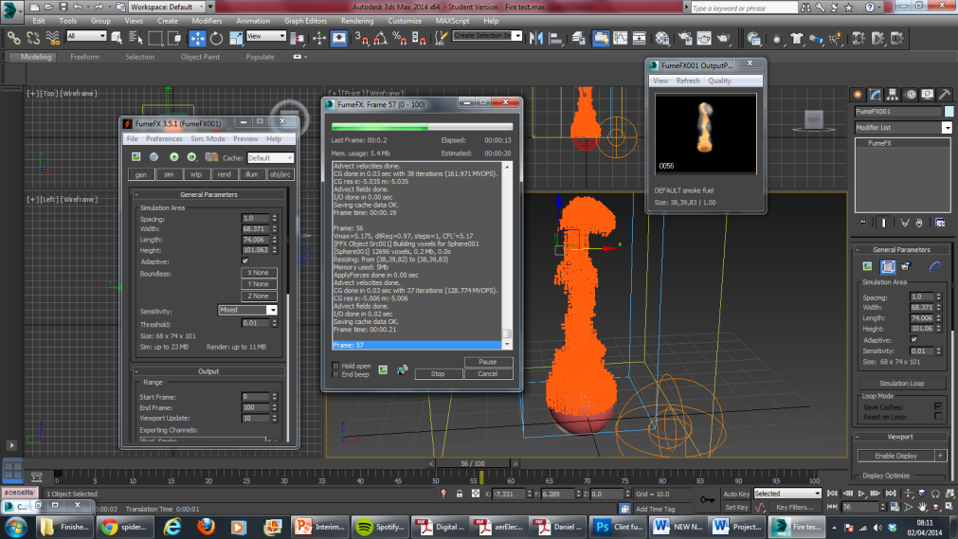

- M
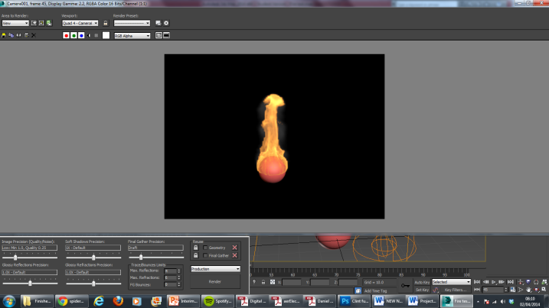

Creating a desert scene
This scene was unsuccessful to completely create due to technical issues. I would be using Mental Ray as the main renderer for my work however to pull off this scene I would have to use Vray, to which I have difficulty to gain access to due to my home hardware not possessing the renderer.
I would have been able to complete the scene within Brunel hardware which does have the renderer, however further planning was needed for me to implement this scene into my new redrafted story. As time become less available to me I had to make the bold decision to just scrap the scene entirely, however I maintain plans to work on the scene within future plans.
Overall, the execution of this test turned to be a failure.
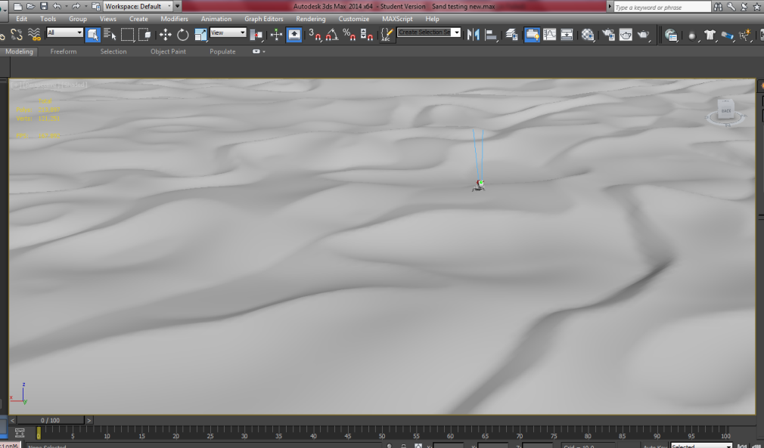
Creating a House Exploding scene
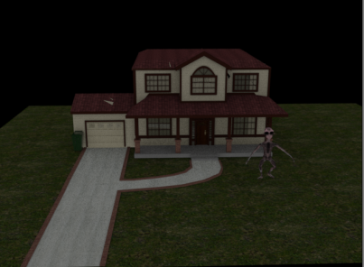
Another task I had to test out was if I can either create the simulation of a house successfully sinking to the ground, or a simulation of a house exploding. I found a script which I believed could help me with the latter solution, named ‘Voronoi’ and it works with creating fractures of a model and then distributing it around its scene in a simulation of explosion, or even crumbling.
This test proved successful, however alike the desert scene I wouldn’t know where and how to incorporate the scene and have it make sense with my new redrafted story, therefore I decided to leave it out.
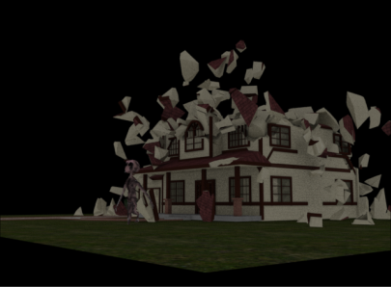
Unwrapping my model

I had a huge amount of difficulties when it came to unwrapping my model, as I tried using the most conventional method to unwrapping organic shapes that there is, being applying a ‘Pelt Map’.
However this would not work for me no matter how hard and how long I tried, and even seeking assistance would amount to nothing. Therefore alternate methods needed to be found to get the very crucial task done.
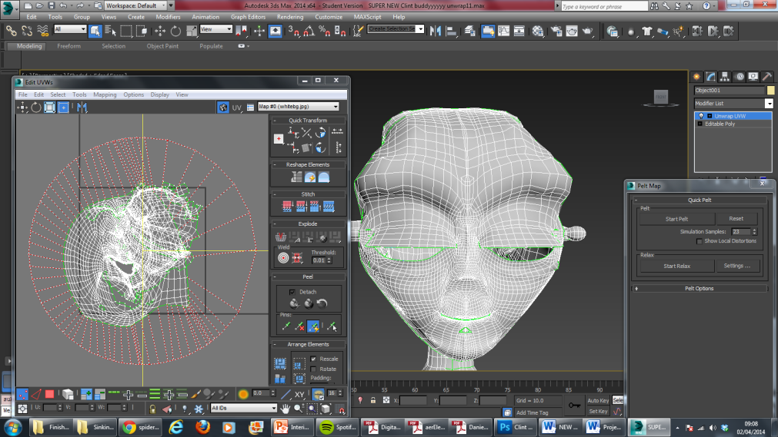
The test was a failure.

Creating Simulated Ice
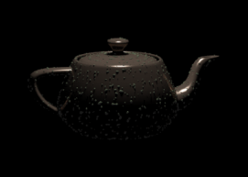
Ice is extremely difficult to replicate realistically within 3D programs such as 3DS Max, therefore a lot of research had to be conducted.
There are built-in plugins within the program to help achieve the desired effects, however doing so successfully is extremely difficult.
‘Thinkbox’ have a particular plug-in known as ‘Frost’, which is much better simulated to achieving the effects, but due to the idea of needing to render within University computers it would require the school to download and install the plugin from the company; which they could not do. I had to try alternative methods to achieving the effects I seek.
I used a traditional plugin for 3DS max which is universal and accessible upon all copies of the program, straight away from initial installation of the program. This plugin is known as ‘Blobmesh’. However the plugin proved to be very difficult to use as it is extremely RAM dependent and so slows down hardware tremendously when trying to achieve the simulation. It is very slow to use and the particle flow and system that is being created did not tend to replicate the seamless and consistent ice texture once completed, but more of a pebble type of texture due to the slowness of the plugin. This was not the effect I had desired, and so although a lot of time was spent trying to implement the outcome, a different path had to be taken to get there.
IMPLEMENTATION

Modelling – The Scenes
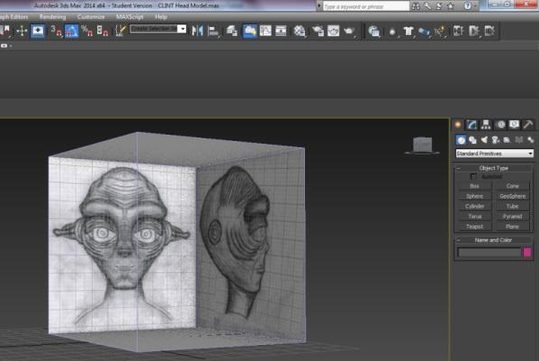
When it comes down to modelling there are a number of different ways you can approach it to getting the results you desire. For the scenes created within ‘Project Clint’ due to how plain I required them to be I decided to use the simplest and most time effective method to get it done and to the satisfaction and accuracy I required. So I modelled the scenes the standard way by using general shapes in the ‘geometry’ section within the toolbar on the right hand side of 3ds Max, and created and configured the shapes to my liking by either resizing, moving and rotating to gain the desired effect.
Some certain objects within the 3D space such as cables had to be created through the use of splines. These would be conducted through creating lines within a 3D space to form general edges, and then extruding them out to fill it in as a 3D object, affected the entire axis, which include height, length and also width.
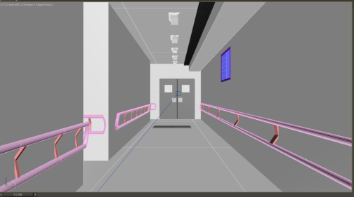

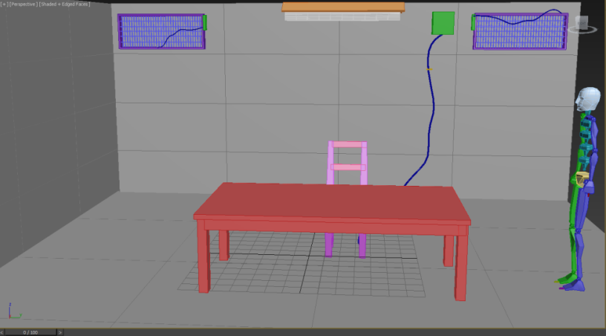

Making the Head – Plane Modelling

Once the scenes were moderately ready, it was time to move onto bringing the drawings of my alien to life, and working on transitioning them from 2D still images into 3D moving images.
The first step to go through when making and bringing the head to life was creating a Reference Box within 3DS Max. The process of this was very straightforward, as it just involved creating a simple box, ensuring it is even along all of its sides, and then inverting the polygons among the sides so that it appears hollow within. And then after that, simply applying 2 textures of the front and side images, ensuring that they have already been perfectly aligned with one another, in order to start the production of the head. When starting the model I first had to model around the eyes in order to build the first defining features of my alien’s face.
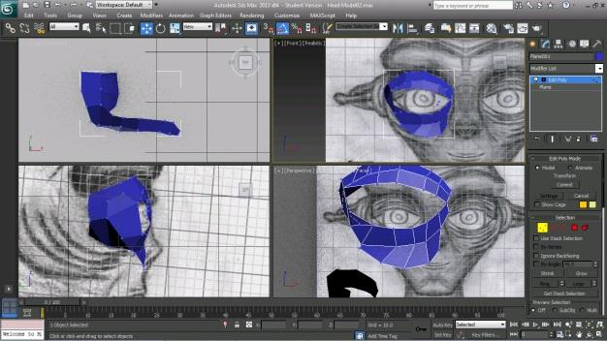
This involved me creating a simple plane, in the size of a small rectangle, and then placing it within an area inside both the front viewport and side viewport, making sure it correlates to the design seamlessly along both of the screens provided by 3DS Max. Once satisfied with the placement I then had to drag out and extrude the edges, so that the plane is not detaching itself to form more of the alien’s face. After a few steps of doing this, I was soon able to create the area of the eye socket.

The eyes needed to both align along with the front view and the side view at the same time when modelling, so there were not many moments that I will perform various tasks in one viewport whilst not taken consideration of how it is affecting the other. Of course, the placing of the planes’ extrusions within one viewport can always be modified even after performing changes to only to another view, however on a tangent this can completely jeopardise the alignment of the model’s constructed mesh and could cause some serious issues in the future when trying to fix it. There is little room for error when creating organic shapes using plane modelling through a reference box; and although extremely effective when recreating accurate 2D images into 3D, a lot of errors can be found if full awareness is not measured when progressing the modelling.

After completing a major section, the next thing I needed to do was actually smoothen out the mesh created by the planes in order for it to accurately reflect the geometry of the face accurately. A face is not built out of rigid edges, but it is smooth and the skin is seamless all around it, so this is the effect we needed to gain.
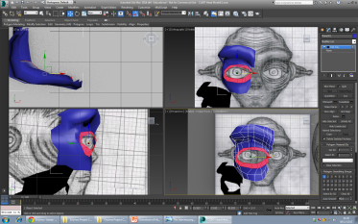
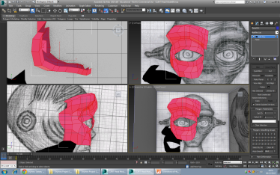
With the alien, the forehead and cheekbones could both be a part of the same skin layer, so this enabled me to be able to highlight the polygons needed to be affected (highlighted polygons are in red) in order to smoothen them out.
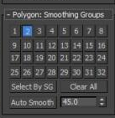
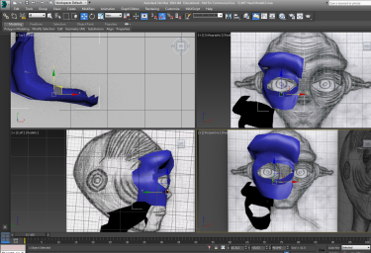
The face possesses a very complex geometry, so things like texture and skin cannot appear too flat. This is where the use of the Smoothing Groups become effective. The cheekbones and the forehead need to seamlessly flow together in level and texture, however the eyelids are a more definitive feature which needs isolation from the rest of the skin on the face. Therefore the polygons which make the eyelids need to be selected separately and added inside a new smoothing group. So where the cheeks and brows would appear in Smoothing group 1 to be selectable, the eyelids would enter a new one; Smoothing group 2

The next step is to apply a mirroring tool, known as ‘Symmetry’, within the modifier list.
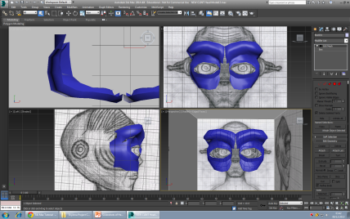

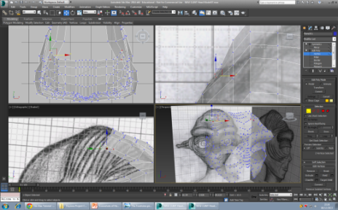
This step wasn’t essential, however it is important to apply it every few steps in order to see if you mesh is coming along in the correct direction. It is very useful and in definite need of application once the half of the head is completely modelled as it tremendously speeds up the production time to where it literally will just mirror the half of the face that is already created in order to form a whole face.
It was also beneficial for me to make the mesh become see-through, in order for me to be able to see past it towards the drawings and get clearer views of everything within my workflow, making sure the aligning went accordingly to the way I want.

With these main steps taken into consideration, it was a straightforward procedure from there to keep on adding and building upon the mesh, to get to the completed build I desired for the head.
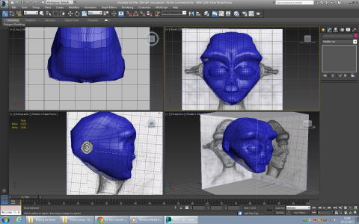
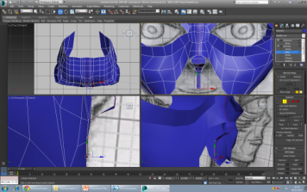
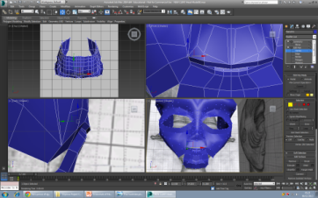
Making the ears involved me using a much simpler process, as it was designed out of non-complex shapes. Unlike the geometry within a face it doesn’t require step by step layers of planes in order to get the general shape I desired. Instead I knew I could speed up the process and create it using several different shapes and then attaching them together to form the shape I needed.
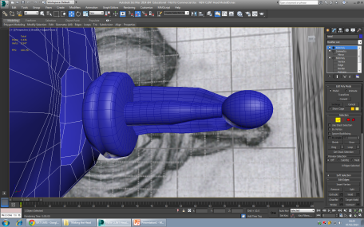
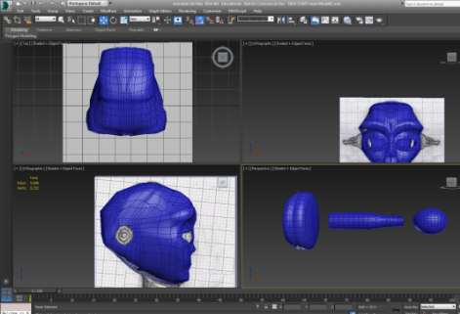

This required me to enter the geometry tab and select different types of shapes, ranging from a sphere for the tip of the alien’s ear and three cylinders then modified to create the main bridge of the ear, the root and the flap.
Again, general tools such as scale, rotation and move allowed me to modify these shapes to the way I wanted, ensuring I can actually use general and simple methods to allow me to create organic shapes which initially may seem complicated in design.
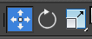

Making the Hands – Box modelling
I decided to move onto the creation of the hands within my next step of the 3D realisation production of Clint.
I originally drew his hands to be extremely long, four-fingered and rather frail. Stereotypical to alien designs however matching perfectly with the design of my alien. However due to my sketch being more conceptual-based, and less accurate and to-scale, I could not take the drawing forward to model from.
In order to get this drawing visualized within a 3D space, I decided to use a method of Box modelling in order to get the workflow started towards conducting the hand design. I followed a tutorial online to guide me with the steps needed to helping me produce the form.
Box modelling would be much more effective when it comes to hands instead of plane modelling as the design of a hand requires less detail in comparison to that of a face. So instead of having to produce the object from point to point, I can just produce a general shape towards creating the main basis to the figure of the hand.

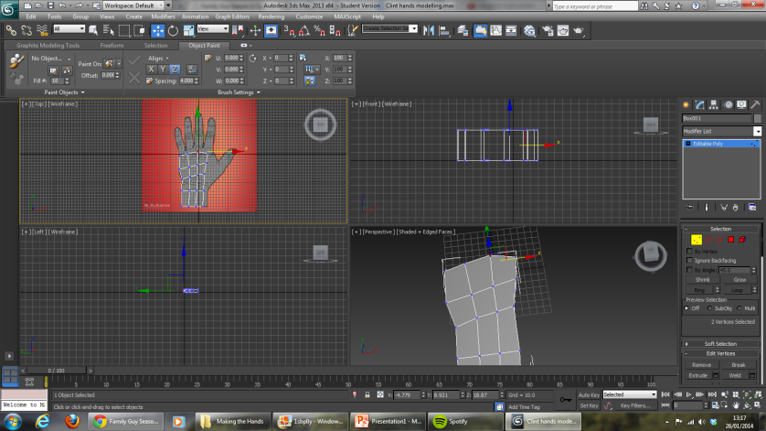

With box modelling, and using the reference sheet available to me through the tutorial; the process allows me to create a shape which would generally be rigid but then alter the shape by adjusting the verts which make up the polygons of it. I can select the verts and move them to desired areas within the area sheet in order to match the main base of the hand towards the design within the reference sheet.
However to be intently noted, I chose not to follow the tutorial step by every step as this tutorial was designed to produce human hands. Clint is not a human, although he possesses very human-like features physically, he still looks awfully different to how a human does. Therefore the tutorial was to be nothing more than a rough plan to enable me to learn the steps to making a hand, however not towards making my own rendition of the hand itself.
The next step after forming the main base of the hand, was to pull out and extrude a section which would form the thumb of the hand. Many extrusions will be needed to form the shape I need, so that was a vital tool within my repertoire in 3DS Max to be at my constant disposal.

Another step to be applied was to form a crease underneath the hand, appropriate to give the hand a more natural and organic shape, rather than it seeming rigid.
The next step was to create a slim cylinder, which will represent a finger and within due time be transformed into one. The way I did this was by adding a few edges through the cylinder in order to create the finger joints. I aligned the edges along with the reference image within the tutorial, bearing in mind I would still change this in order to make it more like the extra-terrestrial version of a design that I wish for.
Finally I reached a milestone of creating the joints within the fingers. From there it is mainly a range of duplication, attaching and modifying in order to get the shape of the rest of the fingers, as well as form the thumb. For further touches slight extrusions would also be added to create the form of the fingernails as well.
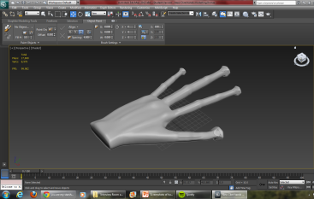
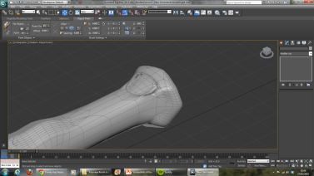

Making the body – Box modelling

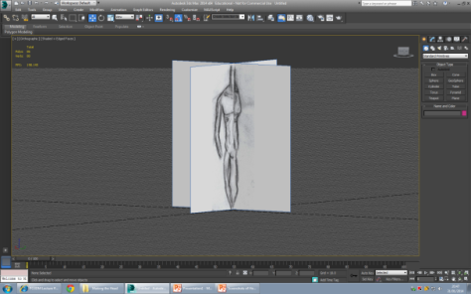
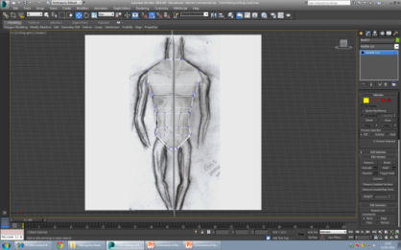

Box modelling was particularly useful when it came to modelling the body for Clint. Just like the hands, I created a box and then morphed it to fit the shape of Clint’s body, using the verts that connect the edges around him. The body was designed using a reference box that connects two planes towards a front image, and a side image.
The legs were then extruded from beneath the torso, along with the feet.

Mistakingly I had only drawn up a reference image for the torso and legs of clint, however I did not do so for Clint’s feet.
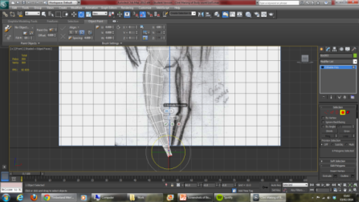
Therefore I decided I need to find a reference image of feet and add it towards my own one, making sure they are perfectly aligned and then proceeding with the extrusions of modelling to get to the desired state I need.
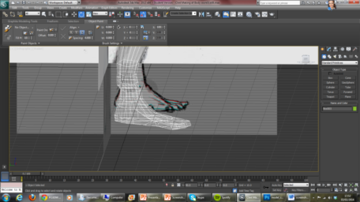

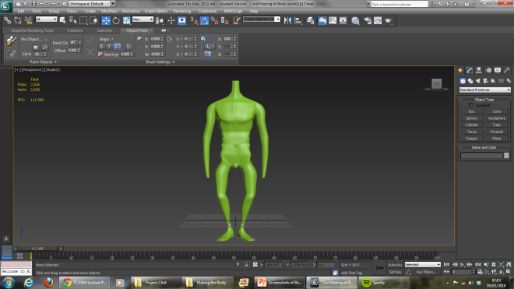

Texturing Clint
Ptex

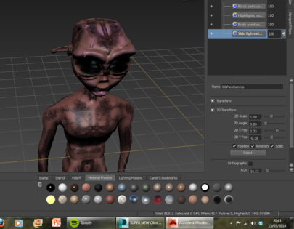
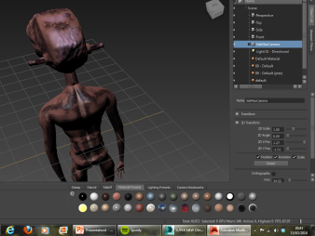

By the texturing stage this is where I came across the most problems. I had uncertainties about how I wanted my alien’s skin to actually look, therefore I decided to use Ptex painting in mudbox which was free from UV’s and allowing me to paint before I have actually unwrapped, allowing me to get a better idea about the way I would like to unwrap him when it came to that. When it comes to unwrapping the alien I needed to know where to focus on in particularly for where the most detail needs to be in, therefore I believed Ptex giving me the power to attend to this before unwrapping was the best solution.

However when it came to transitioning the texture from my ptex model onto my unwrapped model, it proved to be undoable. After several attempts I was not able to take the ptex paint forward onto my unwrapped version, making me lose a great deal of valuable time that I had spent. Although I did learn more about how I wanted my alien’s skin to appear, and Mudbox proved to definitely be the way I wanted to apply it due to the use of tools and methods it has to offer. As I would much rather be painting him on a 3D scale, rather than in 2D with photoshop.

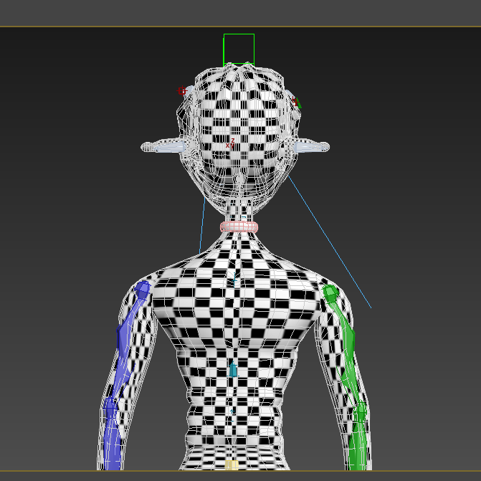

UV Unwrap

After understanding how I wanted the texture to appear on the skin, it was time to UV Unwrap my character. Unwrapping alllowed me to convert the mesh from a 3D scale towards a 2D scale, to simply put it. It has to be a 2D scale to be textured so that any paint files created can read the mesh in order to be incorporated upon it. This is a very strenuous process due to characters possessing a complicated and organic 3D shape. It is difficult to get the program to automatically reform it back into its 2D net. I also tried applying a function of ‘pelt mapping’ and this technique didn’t seem to work for me, for reasons I couldn’t understand and couldn’t afford to waste too much time on to find my answers.
Following an online tutorial however, I was able to figure out how to do this by using cylindrical and box shaped projection maps to read certain parts of the alien’s body, and then step by step unwrap each part seperately.
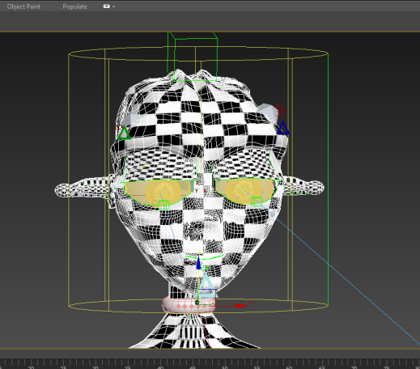
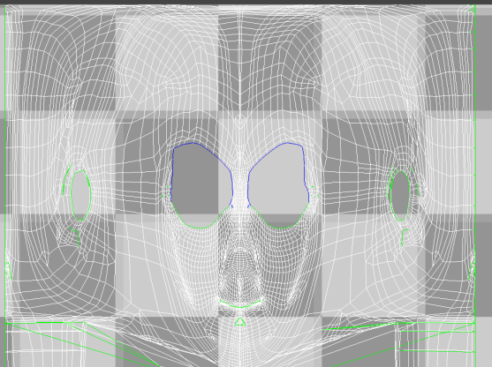

The final product of my alien’s skin through using Mudbox. There are several layers within mudbox that can allow me to understand how I want to texture, including ‘diffuse’, ‘bump’ and ‘specular’ layers etc that are seen within 3DS max in order to get a more complete and vivid texture.
With Mudbox, I used the air brush tool in order to spray the colour of the skin on, and also the colour of the highlights upon the face to create a blush, making the alien appear more cute and cheeky rather than intimidating and terrifying.
I used a dry brush to apply the markings on the skin, to make it slightly appear as if the skin is carved. And I also used normal paint brushes to apply other details within the skin, such as the dark eye lids that Clint possesses, and small highlights over the body, amongst with other details.

One of my other considerations when texturing, was to provide Clint with a much colder shade of grey. However after close thought I decided this wouldn’t be the best look for Clint, as the grey made him appear much more sinister and cold than he actually is. Clint may not the typical portrayal of a protagonist, however he is still good and there is no argument to it. The grey would symbolically suggest him as being bad, which for an animation would go against typical conventions and confuse the character’s depiction from the viewer.
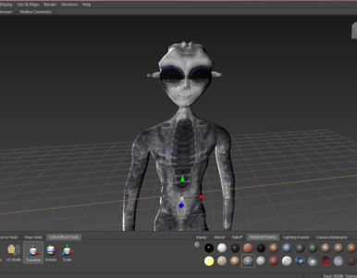
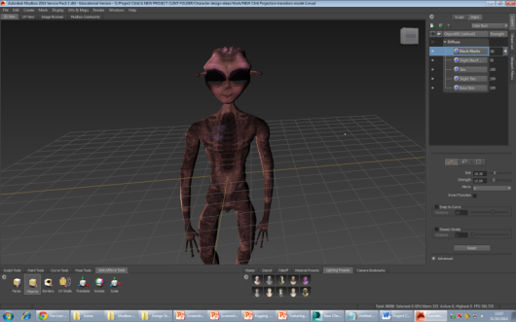

Key frame animation was also used upon Clint’s texture from grey to red within the scene, through creating a ‘Falloff’ diffuse channel and applying both of the textures that I need, instead of just one of the textures with a normal diffuse channel.
The same technique was applied to Clint and the teapot within one of the scenes, when he freezes it in order to give the procedural effect of something freezing to ice.

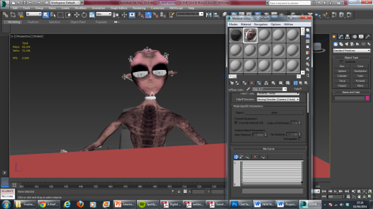
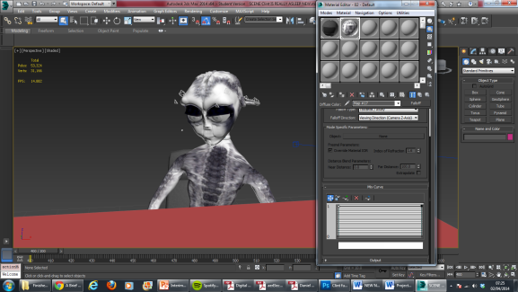

Texturing the Scene

Due to the scenes being made mainly with standard geometry, it was not entirely difficult to texture the scenes. The function of standard ‘UVW wrap’ was enough for me to use normal shapes as guides and outlines to texturing the shape. If I had an image as a texture, instead of it remaining 2D it will now take on a more 3D shape such as a cube or sphere, and then use that as a basis on how it needs to apply itself as a texture on a model. This technique would be repeatedly applied towards models of various shapes, and would come out effectively. If the shape was more complex and made by the attachment of multiple models, it could simply be detached again and textured separately; then reattached to form the original shape once more.
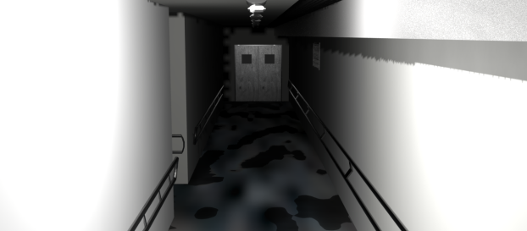

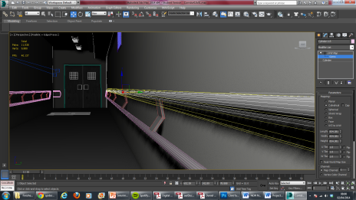
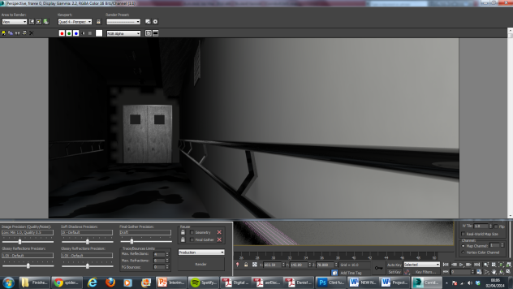

Using Plugins
FumeFx was of immense use to me when creating my animation, as I needed to use something I can efficiently and effectively create fire with, to the extent where I had full control over the composition and disposition of the flame.
The features within FumeFX allowed me to easily keyframe animate the movement of the fire, control the colour and contrast of the fire, the opacity of the flames, colour and density of the smoke, whether or not I wanted the fire to create the smoke after dissipating or before etc. This was important to making the flame seem controlled and manipulated with the alien’s hand, rather than move on its own like any other regular flame.
FumeFX was an extremely handy program which much effective use, which I will definitely consider using again in future animations I wish to make.
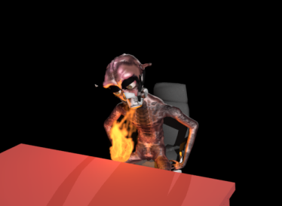
When creating the fire I had to also key frame a warm, orange ambi light in order to give the sense that the fire was emitting this light from its flame. Key framing both the fire and the light was a rather difficult process to do realistically as I needed the fire to rise towards its climax and then fade at its end; therefore the flame had to be scaled up and down appropriately in animation mode. Another issue of animating it which proved more difficult was moving the fire seamlessly and cooperation with Clint’s hand, which was supposed to be the source of the fire. As mentioned before, due to the actual source of the fire being a sphere I had made and then hidden, it mean I had to actually key frame both the ball and the flames themselves in order to give the appearance that the flames are actually attached and have been parented to Clint’s hand. Making it seem my alien actually has the complete control over the flames.

Motion Capture for Clint

Performing
Performing motion capture for Clint proved to be rather tricky as his body was completely different to my own, so I had to bear that in mind with my own physical movement. His back is slightly hunched; his legs prominently face outwards, his arms dangle. With all of this in mind I had to make sure that I was implementing the features within myself.
I decided to adjust my body towards the same posture as the alien, in order to re-enact his body.
I also decided to use much accentuated movements in order to capture the hilarity of the scenes to the extent I liked, rather than downscaling my acting performance and making it seem too normal and realistic.
Setting up
Before shooting, the first thing we needed to do was open up Blade and turn on the machine for the cameras. Then we needed to work our way to calibrating the cameras, in order for them to pick up the motion with the space which would act as a 3D virtual scene. To calibrate the cameras, I needed to use the calibrating wand keep waving it within the space for it to eventually recognize the environment that will be performed within.
The next step to do was to calibrate the floor, in order for the cameras to understand where the base is within the scene.
After this I had to get in the suit, with the infrared balls attached to specific areas within my body so that the cameras could capture this and understand the motions I would be making. Finally, I decided to take a desk and chair towards the centre of the room in order for me to sit and perform on. This would allow me to accurately move as to how the alien should move on the desk.
Capturing
The next step now is to capture the take. So before I did this I had to set up a ROM (Range of Motion) in order to ensure that my movements were accurately captured by the cameras.
Once this is finalized, I then go on to record the take. Go into a T-pose so that the cameras understand this is the beginning or end of a take, and then start the performance.
Cleaning Up
The cleaning up process can be long and tedious; however because of a recent update of the Vicon motion capture system upon the cameras in Brunel University, they were accurately able to pick up the data I had sent with my body’s capture. I was not adept enough yet with Vicon Blade in order to completely start to clean up the footage there, so instead I moved onto MotionBuilder which I found to be easier to understand and use, speeding up the productivity of my work.
I first had to convert my model into an FBX, to make it fully render-able within MotionBuilder. From there I can then apply any changes and fixing that I needed to make, by working with key frame animation in order to manually fix some frames that went off or undesirably within the takes.
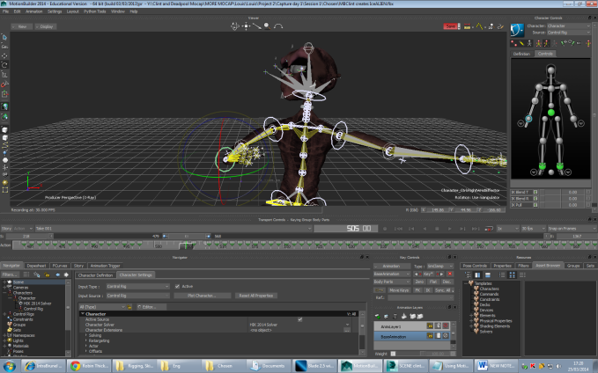

Rigging, Skinning and Weighting
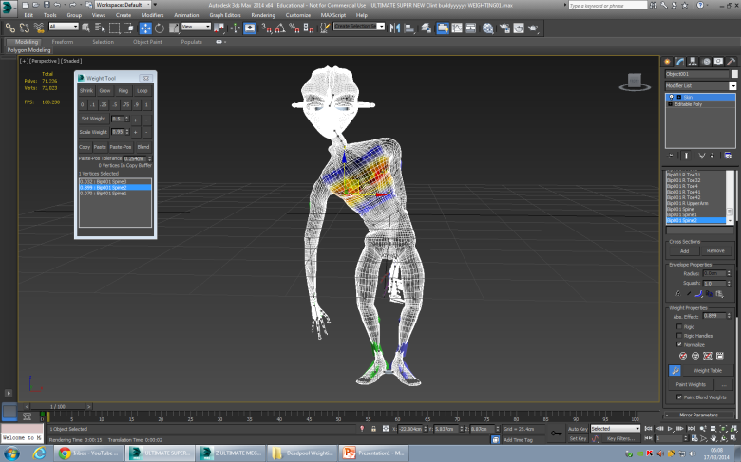
In order to ensure that Clint would move effectively along to the motion capture I had shot for him, I needed to make sure that all of the rigging, skinning and weighting had been applied correctly to him. These steps are crucial to the success of the character’s movement as if not done well; the mesh of the character could abruptly stretch unintentionally, could distort or in worst case scenarios could even collapse once the character tries to imitate my own performance.

Facial Rigging
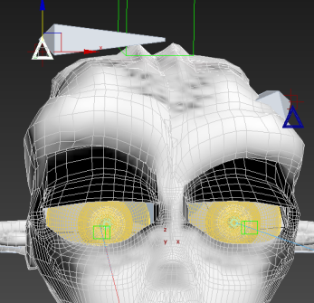
Clint has very definitive features within his face to make it reasonable to rig. I had created him with enormous eyebrow bones within his mesh, to which I modified by adding bones inside of, in order for me to move the bone when animating and control it to help provide Clint with a great array of facial expressions, with just the bones eyebrows.
A bone was also added to Clint’s jaw, so that when he supposedly speaks the jaw could be animated to suggest he is actually using his mouth to talk, even if it is covered by his mask.
3 separate Bones were placed within each ear, to construct the figure of its flap, tip and base. This also allowed me to animate the ears so that they can slightly move in any direction when Clint is performing energetically.
In order to animate the eyes they needed to be parented to the head of the alien, so attached to the head bone for Clint’s biped. This was helpful to make sure the eyes don’t fall out of place, and was only affect in rotation by its pivot point.
Originally I had a dummy box for each eyeball to make animation far easier to control over the eyes, as if I were to move the dummy the eyeball would move alongside with it. However access to this control unfortunately disappeared, once I converted the model into an FBX model so that the motion capture data could be applied. This was a setback as it rendered the time I used to create the control virtually pointless for this project; however I was still able to animate it more traditionally by just rotating the eyes themselves. Nevertheless this was at times detrimental as when clicking the eyes it was easy to interfere and interrupt other controls or facial features that were apart of Clint’s model, so mistakes could have been made easily due to this.
Due mainly to not having any access to facial motion capture technology, key frame animation by hand was then needed to allow Clint to pull off any of the expressions I needed him to make. With the idea of mixtures capable of being made through the different adjustments that can be tweaked within the bones on the face as well as the body; expressions of shock, sadness, anger and even shyness could all be implemented into the act in seamless cooperation and combination.

Cinematography
Animations need just as much careful consideration as actual film and movies when it comes to cinematography, as all forms of media and mediums are still telling a story. So every factor of it needs to tell it in a compelling way, using artistic or technical methods as well to get the job done.
Camera shots were to be highly considered in order to get a better telling of the story I wish to offer. There are two ways in which I considered going about this.
Due to the artefact being primarily in interview form, usually only one or two cameras are at use at most, and they happen to be static. Interviews are not cinema; they are generally not purposed with bringing entertainment but more for the goal of receiving information.
However that is also where my artefact will be straying past the generalisation of conventional interviews. Clint is not a conventional character and so he will not be conscripted by a conventional scene. I chose to mix it up for the sole purpose of providing a more entertaining artefact than what would be if I were to use only static cameras. Moving and animated cameras are much more dynamic and artistic, and actually symbolise the tones in the animation which is supposed to reflect upon the reader.
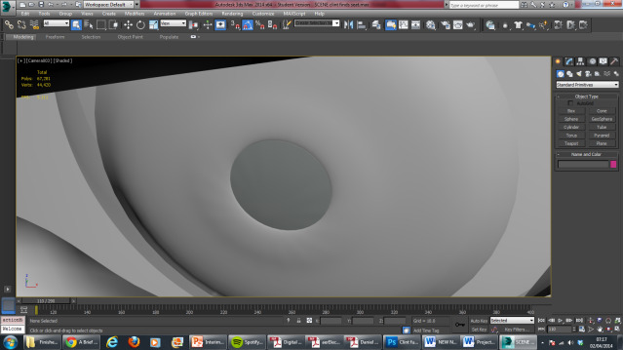
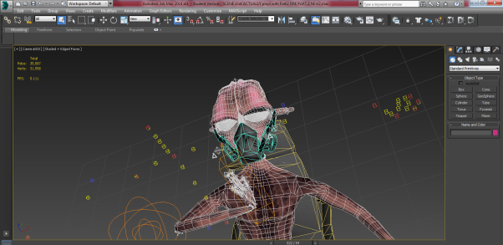
Examples include ‘shaky’ cameras which were used in order to connote the action that is happening within the trailer, along with emphasize upon the jaggedness in Clint’s execution of showing off his abilities. ‘Close ups’ are at work in order for the audience to feel very much up close and personal with the alien, and understand that Clint is very ‘in your face’ at nature. The camera pans and follows his body at times so that emphasis is drilled into the audience’s minds that Clint is our main character, and everything is about him, just the way Clint wants it to be. But also importantly, static cameras are still used in order to still depict the idea firmly that this is an interrogation, and although comedic it still maintains tones of seriousness; it is just hard to see through Clint’s overwhelming folly and absurdity, along with his sense of charm.
In order to get the camera moving along with the scene, Key Frame Animation was executed in order for the camera to fly through the action and capture the shots I desired. Much like moving characters, key framing for cameras worked similarly. However it did need constant consideration as like with a human-being for example the camera base itself only acts as a movement similar to a head on a body. However the camera’s sight and target acts as the eyes, therefore two different factors needed to be controlled when performing animation on the camera in order for it to work effectively.
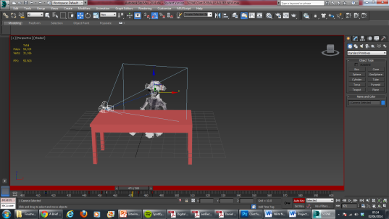
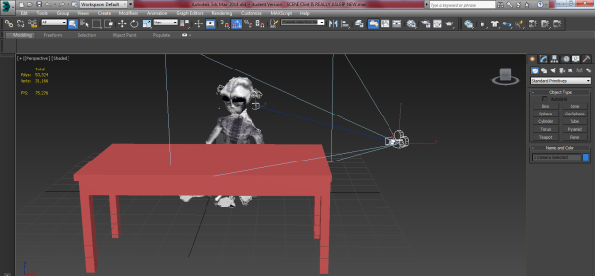

Lighting and Rendering
Lighting was simple for my scenes because there were not many objects to be present within the scene. I focused my lighting mainly on lighting up Clint’s body within the scene, therefore I placed two Mental Ray area lights from opposite directions to hit and target Clint, just to make sure that he is well lit up and can be seen clearly in full detail, as he is the main and only character present on screen.
I decided to render on low-mid settings through Mental Ray, simply because time was getting tight and I had always known I wouldn’t need high render with high settings as I am not trying to create anything that replicates photo-realism.

Assets purchased/ downloaded
- Due to my prior understanding of knowing how difficult and time consuming it would be to move Clint’s lips and lip-sync him to words, I decided he would need a mask to cover up his mouth. The mask was taken from a game character within the website TF3DM.com
http://tf3dm.com/3d-model/edf-soldier-52092.html

- I had originally made a chair for my scene, however the chair I performed upon had wheels; whereas the chair I created didn’t. This led me to decide to download a chair with wheels from the website TF3DM.com
http://tf3dm.com/3d-model/office-chair-321.html

- Eyes were crucial to my model as I know how much they can suggest in terms of action and connotations. I already knew how to create eyes, yet I had seen a perfect set for my character therefore I decided to purchase and download them instead.

http://www.creativecrash.com/3d-model/realistic-human-eye-3d-model

EVALUATION

Character Development
Something to have considered and further worked upon may have been to give the antagonist more of a role within the animation. Due to how time consuming and difficult it can be to design, model, texture and animate characters I decided it would be best to only model one character and therefore it was obvious only one will be in great focus. However the chemistry and levels of interaction may have proved more exciting with both characters to be visually presented on screen. As
“The dominant mistake writers often make when developing and submitting their storyworld project is to focus on a single character with a single goal and subsequently a singular plot. But we’re not looking for ‘a’ story, we’re looking for a whole world of stories. In terms of character this often means shifting the emphasis away from an individual character and onto communities of characters.
Any storyworld – whether it’s real-world, intimate and contained, or other-worldly, fantastical and huge – will be home to groups of character that share common goals and obstacles; in other words communities.”
http://www.thewritingplatform.com/2013/03/immersive-writing-lab-series-how-to-create-characters/

Keyframing instead of Motion Capture?
Clint needs to move realistically yet also non-realistically. He needs to move in a life-like manner to give the appearance that he is actually alive and the image of him to become more immersive within the minds of his audience. However he also needs to move unrealistically, defying the conventional movements of living human-beings on our planet as he is not from our planet. He is an alien with an unbearably wacky and silly persona, therefore his movements should feel also feel surreal to emit this. His movements should capture forms targeted towards humour more, rather than realism as that is the main approach towards the animated trailer.
Clint is not realistic by any means, and worst of all his body is rather dissimilar to a human beings. He has very long arms compared to his short legs, his back is hunched, his arms are towards his front rather than by his sides, his feet and legs face sideways naturally rather than to the front of his body. His whole anatomy and skeletal figure is wrong in comparison to mine, his Motion Capture actor, making it extremely difficult to capture perfectly.
I learnt that Motion capture for cartoon-like characters are not a bad idea, however it does prove to be much more difficult than I had anticipated. It wouldn’t look right for realistic characters to be animated in a ‘toon-like’ fashion, just as how it might appear to seem strange for the toon-like characters to be animated in a realistic standard as well. Consistency could be thrown off as the plotting of visuals and movement are not fully and seamlessly synchronized with one another. It is difficult to create motion captured shots to accentuate a CG character as we are real and not animated; we have certain restrictions within our physical and human embodiment that can’t be compromised. In order to get the ideal, comical, ‘toon-like’ animations they would certainly have to be key framed or altered, which is a very difficult task to apply towards motion capture as there is a key frame in-built within every single frame of the data.
Though there is much to argue for why keyframe animation is still the way to go for lesser realistic characters, there is still plenty to be vouched for establishing Motion Captures new dominant role and status when it comes to animation, as I discovered. Motion Capture can be performed much quicker when used right, and although proving difficult when altering the animation it can still offer some very interesting and unique takes to how models should move. Although motion capture for now may seem to be of better use for more realistic characters that have a more complete axis of movement to them when it comes to the entirety of their bodies ranges of motion.
So performing motion capture may actually have not been the smartest idea, even though it is always an ideal one to go with.
In accompaniment to this statement, it is to be noted that motion capture was actually a completely new medium for myself to use. Yet another criticism to be made may be on my own sense of ambition. Perhaps I should not have taken such a massive leap to head straight towards Motion Capture when having never used it before, for such a big project.
Within MotionBuilder when having to clean up, I noticed some of the movements I actually key framed myself manually actually turned out better than a few of the movements I performed with motion capture. So for Clint maybe the more traditional methods of animating could have proved to show even greater results, if followed through all of the way.
Time Management
Here is a sheet of my Gantt chart, which I created near the start of my project to make sure I can keep on schedule.
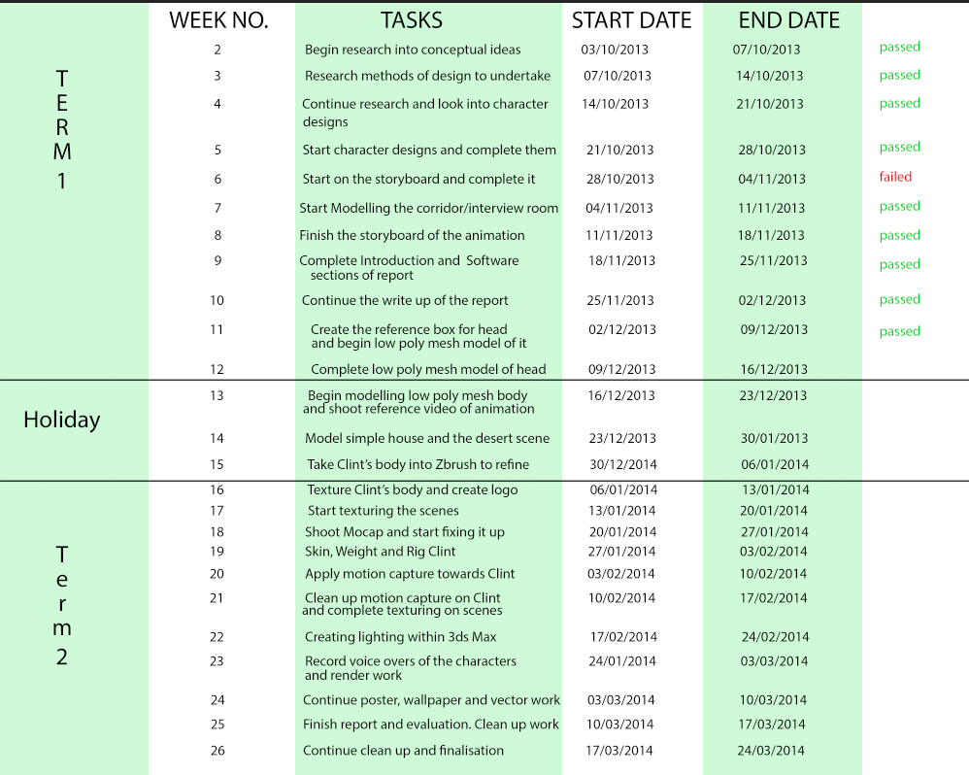
Please zoom into the page to get a clearer viewing of the Gantt chart.
My time management started off well but then fell towards the later stages of the production, due to various technical and personal issues I had come across. Unfortunately these issues could not be avoided at the time, and therefore I lost valuable production time because of such. My Gantt chart was not followed through with completely, forcing me to rid of some of the ideas I had previously wished to follow through with in the animation.

Voice Acting
Originally I had a good friend of mine to help me achieve some of the voice acting to the standards I wished, as he is an aspiring voice actor and animator himself. Although due to unfortunate timing and both of our busy schedules with our projects we couldn’t keep in touch as much as we thought we could to get the voice acting done together. Therefore I had to produce it all by myself, and whilst satisfied with it I do still believe it may have come out even better with his assistance as well.

The Aesthetics
I am really proud with how the aesthetics of the production turned out. I had never before created a character from scratch to then take it onto animation and watch it come to life through Motion Capture. Yet I have achieved this and I believe the quality of the model and scene are of a great standard to which I could be proud of. I knew it would not look as good as ‘Insomniac Studios’ ‘Ratchet and Clank’ Series, yet I believe I successfully emit the same tones and feelings that can be gathered within those productions as well. Perhaps if I keep working on it and practicing then one day I can make my animation reach that benchmark, and perhaps even surpass it.

Future Development
I have one simple and main aim to my future developments for the project, which is to keep working and improving on it with every opportunity and thought I find. I am truly engulfed and passionate with bring Clint’s character to life and recognition, and have thoughts of creating several diary entries to explore Clint’s bizarre personality even further. First starting with completing the ones shown within the storyboard, then expanding towards other types of scenes when the story has found its full basis and footing.

SWOT Analysis

Strengths:
- My interest in animation encouraged me to learn more about character animation and stick through with it, even considering all of the setbacks.
- Character design is strong and consistent from Design process on towards Implementation.
- My animation successfully delivers upon humour, and Clint is a welcomed protagonist.
Weaknesses:
- Although I had some knowledge, I had no prior experience with motion capture.
- Time management needs improving.
- Had to learn a huge array of software and methods for this one project. For future this is beneficial but for the present this was extremely time-consuming.

Opportunities:
- Due to the time limitation on the production of the artefact and report, I had no time to create and animate my antagonist’s character physically. Would like to in future.
- Would like to incorporate the rest of my scenes within my storyboard onto my animation in future.
- Could have perhaps considered working alongside a concept artist to help me come up with ideas for my character’s physical representation quicker.
- Should have utilised the idea of working alongside voice actors for my project, and found a better means to keep in touch with the voice actor I already had.

Threats:
- Fell badly ill towards the last phases and stages of the project leading to the deadline.
- Rendering proved to cause a lot of issues, as some scenes didn’t render properly and due to the lack of time I had they had to be scrapped.
- 3D is time-consuming to produce at a decent standard.

CONCLUSION
This project has allowed me to profoundly appreciate and admire many forms of 3D animation, through whatever method was involved in producing it. The difficulty of recreating a character initially built only from one’s mind is truly high and challenging, yet the thrill of seeing your character come to life makes it definitely all worth it in the end. I am proud to have worked on such a project.

BIBLIOGRAPHY
- Create a Realistic Fireball using FumeFx - CGRats - CG Tutorials and resources. 2014. Create a Realistic Fireball using FumeFx - CGRats - CG Tutorials and resources. [ONLINE] Available at: http://www.cgrats.com/create-realistic-fire-using-fumefx.html.
- Evolution of Humans and Apes » Jody Hey. 2014. Evolution of Humans and Apes » Jody Hey. [ONLINE] Available at:http://genfaculty.rutgers.edu/hey/human-origins
- Meet the Scout - YouTube. 2014. Meet the Scout - YouTube. [ONLINE] Available at: https://www.youtube.com/watch?v=geNMz0J9TEQ.
- Star Wars Episode III: Creating General Grievous Webisode - YouTube. 2014.Star Wars Episode III: Creating General Grievous Webisode - YouTube. [ONLINE] Available at: http://www.youtube.com/watch?v=tBOoZ5Tuh2o#t=244.
- Afterworks - Sitni Sati. 2014. Afterworks - Sitni Sati. [ONLINE] Available at:https://www.afterworks.com/FumeFX/5years.asp?ID=19.
- How To Create Characters. 2014. How To Create Characters. [ONLINE] Available at: http://www.thewritingplatform.com/2013/03/immersive-writing-lab-series-how-to-create-characters/.
- Office Chair - 3d model - .obj. 2014. Office Chair - 3d model - .obj. [ONLINE] Available at: http://tf3dm.com/3d-model/office-chair-321.html.
- Realistic Human Eye 3D Model. 2014. Realistic Human Eye 3D Model. [ONLINE] Available at: http://www.creativecrash.com/3d-model/realistic-human-eye-3d-model.
- EDF soldier - 3d model - .obj, .dae. 2014. EDF soldier - 3d model - .obj, .dae. [ONLINE] Available at: http://tf3dm.com/3d-model/edf-soldier-52092.html.
- Principles of Animation. 2014. Principles of Animation. [ONLINE] Available at:http://minyos.its.rmit.edu.au/aim/a_notes/anim_principles.html.
- Faceshift: Markerless Motion Capture - YouTube. 2014. Faceshift: Markerless Motion Capture - YouTube. [ONLINE] Available at:https://www.youtube.com/watch?v=24qUFDdZAG8.
- Unwrapping Characters in 3Ds Max - Beginners Guide, Unwrap UVW - YouTube. 2014. Unwrapping Characters in 3Ds Max - Beginners Guide, Unwrap UVW - YouTube. [ONLINE] Available at:https://www.youtube.com/watch?v=HO0oiVYKH8c.
- Meet The Experts: Freedom from UV's, Ptex Painting in Mudbox 2014 - YouTube. 2014. Meet The Experts: Freedom from UV's, Ptex Painting in Mudbox 2014 - YouTube. [ONLINE] Available at:http://www.youtube.com/watch?v=ElVbyLyD_ts.
- CG Education. 2014. CG Education. [ONLINE] Available at:http://www.neilblevins.com/cg_education/ptex/ptex.htm.
- Thinkbox Software - Frost. 2014. Thinkbox Software - Frost. [ONLINE] Available at: http://www.thinkboxsoftware.com/frost/.
- Escape From Planet Earth Trailer (2013) - YouTube. 2014. Escape From Planet Earth Trailer (2013) - YouTube. [ONLINE] Available at:https://www.youtube.com/watch?v=Q1NhAUsyslk.
- Seven Character Types That Build Your Story. 2014. Seven Character Types That Build Your Story. [ONLINE] Available at:http://www.adventuresinyapublishing.com/2011/10/seven-character-types-that-build-your.html.
- Fracture Voronoi | ScriptSpot. 2014. Fracture Voronoi | ScriptSpot. [ONLINE] Available at: http://www.scriptspot.com/3ds-max/scripts/fracture-voronoi.
- The Hobbit 'the Making of Gollum' - YouTube. 2014. The Hobbit 'the Making of Gollum' - YouTube. [ONLINE] Available at: https://www.youtube.com/watch?v=TboSe_0zJGA.
- James Earl Jones On Being The Voice Of Darth Vader - YouTube. 2014.James Earl Jones On Being The Voice Of Darth Vader - YouTube. [ONLINE] Available at: https://www.youtube.com/watch?v=RAJgnUix2kI.
- CGI VFX Behind The Scenes HD: "Ted" Using the Mocap system MVN - YouTube. 2014. CGI VFX Behind The Scenes HD: "Ted" Using the Mocap system MVN - YouTube. [ONLINE] Available at:https://www.youtube.com/watch?v=hZhiwppXdJ8.
- Benedict Cumberbatch Performs MoCap 'Smaug' In Making Of Video - Hollywood Reporter. 2014. Benedict Cumberbatch Performs MoCap 'Smaug' In Making Of Video - Hollywood Reporter. [ONLINE] Available at:http://www.hollywoodreporter.com/behind-screen/benedict-cumberbatch-performs-mocap-smaug-682351.
- Goodbye Uncanny Valley: NVIDIA's 'Face Works' Brings Shocking Realism To Facial Animation - Forbes. 2014. Goodbye Uncanny Valley: NVIDIA's 'Face Works' Brings Shocking Realism To Facial Animation - Forbes. [ONLINE] Available at:http://www.forbes.com/sites/jasonevangelho/2013/03/20/goodbye-uncanny-valley-nvidias-face-works-brings-shocking-realism-to-facial-animation/.
- Seven Things I Learned About Animation From ‘Monsters University’ Supervising Animator Scott Clark. 2014. Seven Things I Learned About Animation From ‘Monsters University’ Supervising Animator Scott Clark. [ONLINE] Available at: http://pixartimes.com/2013/06/12/seven-things-i-learned-about-animation-from-monsters-university-supervising-animator-scott-clark/.
- Seven Things I Learned About Animation From ‘Monsters University’ Supervising Animator Scott Clark. 2014. Seven Things I Learned About Animation From ‘Monsters University’ Supervising Animator Scott Clark. [ONLINE] Available at: http://pixartimes.com/2013/06/12/seven-things-i-learned-about-animation-from-monsters-university-supervising-animator-scott-clark/.
- Markerless Facial Motion Capture Tech Demo 2 - YouTube. 2014. Markerless Facial Motion Capture Tech Demo 2 - YouTube. [ONLINE] Available at:http://www.youtube.com/watch?v=3R2K5yXpWIM.
- The Incredibles Interview Scene - YouTube. 2014. The Incredibles Interview Scene - YouTube. [ONLINE] Available at: http://www.youtube.com/watch?v=YveIFphNcp4.
- I, Robot - YouTube. 2014. I, Robot - YouTube. [ONLINE] Available at:http://www.youtube.com/watch?v=05bGPiyM4jg.
- Batman Arkham City: Hugo Strange Trailer - YouTube. 2014. Batman Arkham City: Hugo Strange Trailer - YouTube. [ONLINE] Available at:https://www.youtube.com/watch?v=muCtJsy-d9w.
- Half-Life 2: Episode 2 G-Man Scene - YouTube. 2014. Half-Life 2: Episode 2 G-Man Scene - YouTube. [ONLINE] Available at:https://www.youtube.com/watch?v=vk8IdP-upKY.
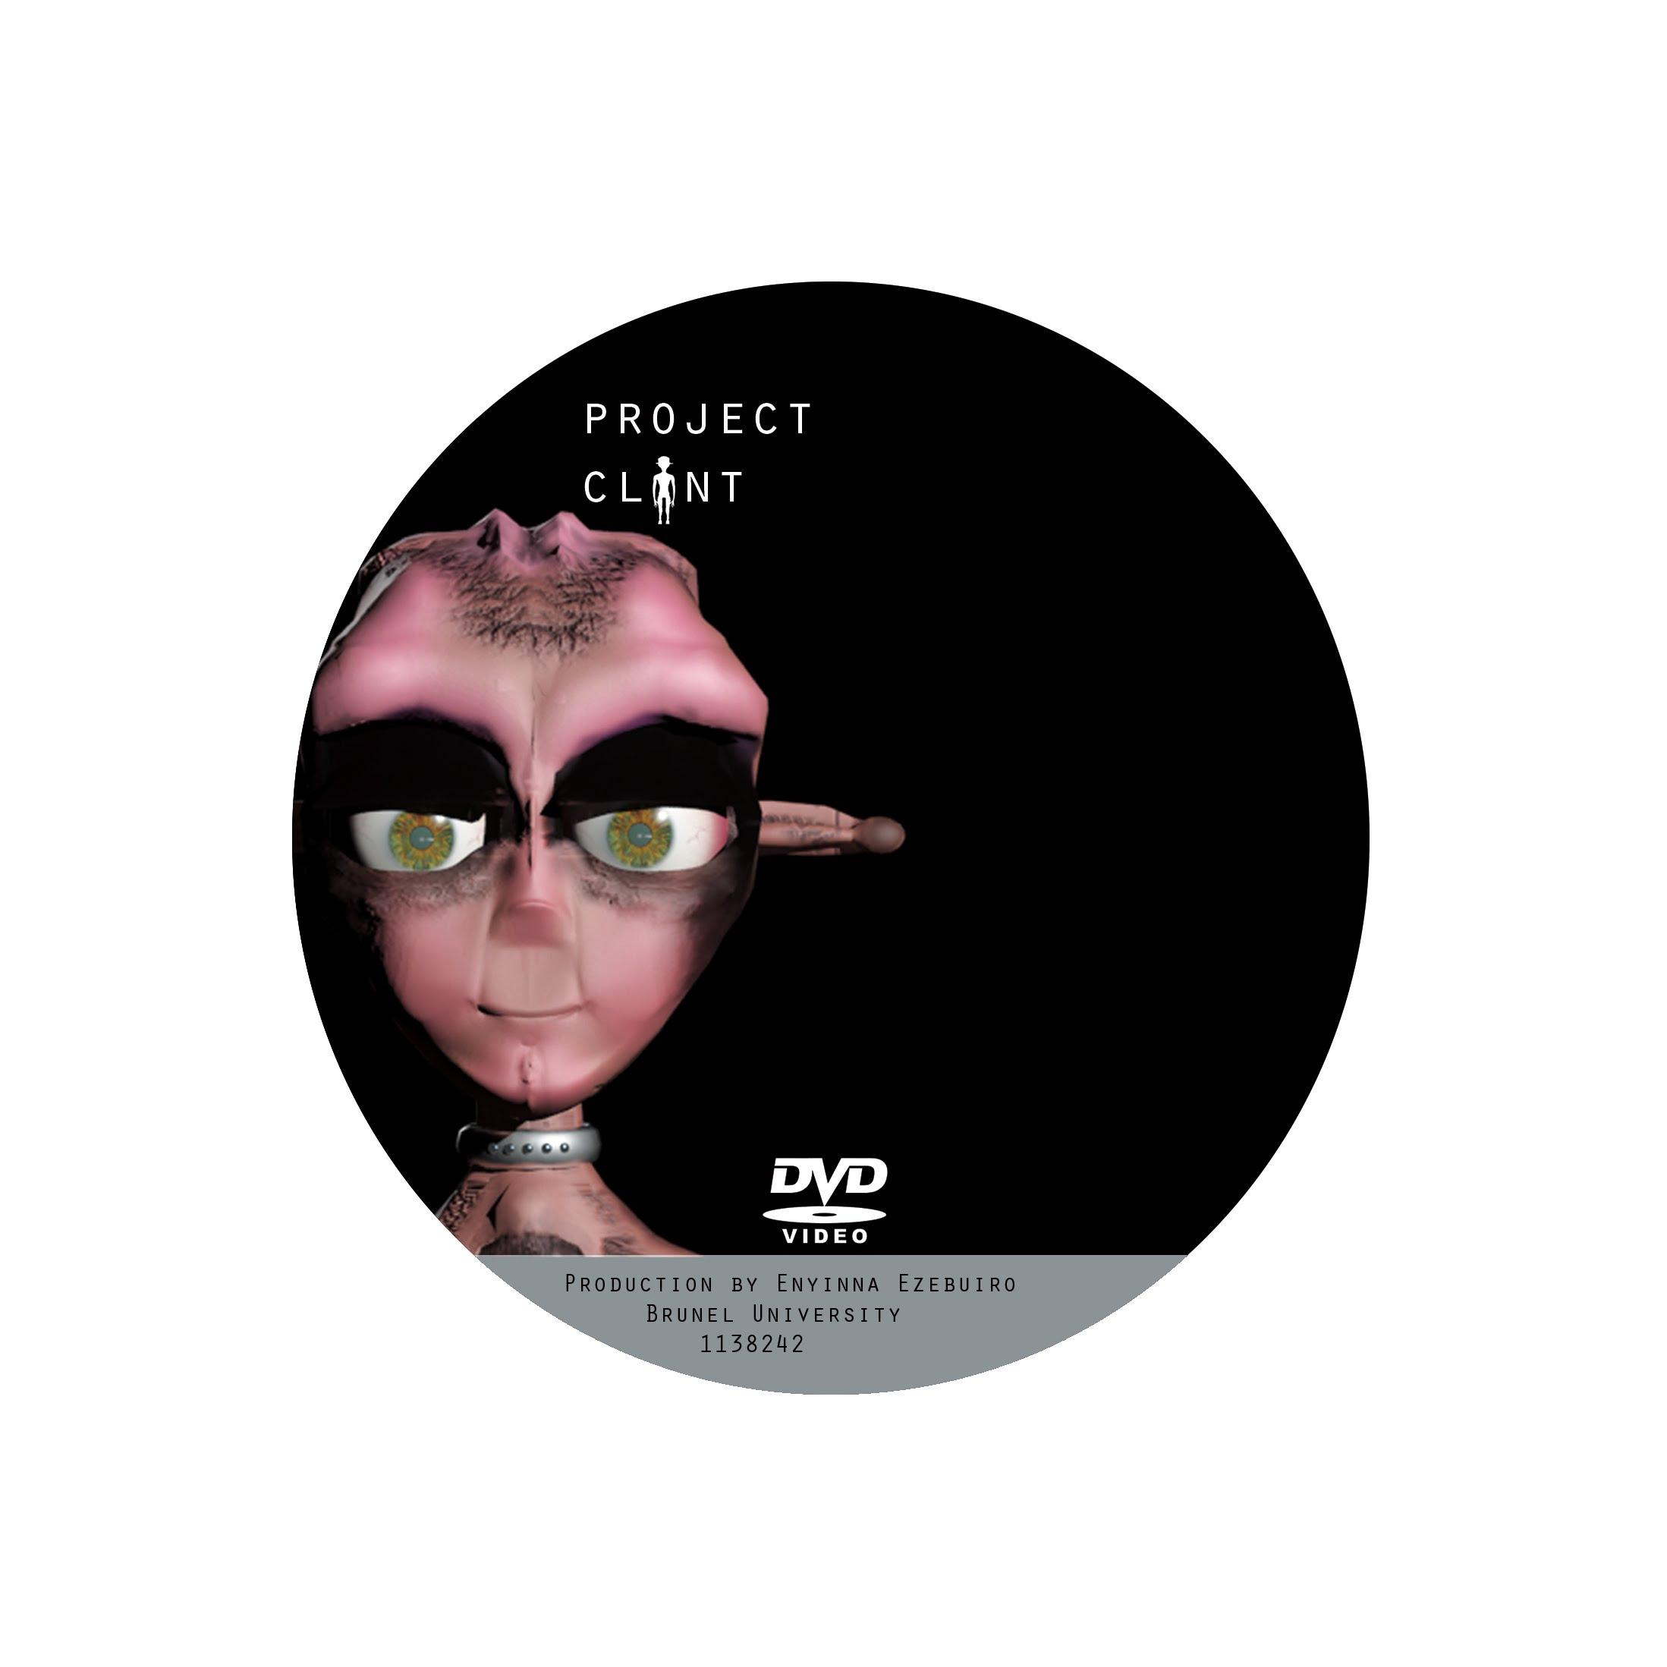
- Types of Heroes - Heroes Wiki. 2014. Types of Heroes - Heroes Wiki. [ONLINE] Available at: http://protagonist.wikia.com/wiki/Types_of_Heroes.
- Main/Idiot Hero - Television Tropes & Idioms . 2014. Main/Idiot Hero - Television Tropes & Idioms . [ONLINE] Available at:http://tvtropes.org/pmwiki/pmwiki.php/Main/IdiotHero.
- The four kinds of heroes. 2014. The four kinds of heroes. [ONLINE] Available at: http://www.martinturner.org.uk/martins-notes/the-four-kinds-of-heroes/.
- Joe Navarro, 2008. What Every BODY is Saying: An Ex-FBI Agent's Guide to Speed-Reading People. 1 Edition. William Morrow Paperbacks.
- Barrett Fox, 2003. 3ds max 6 Animation: CG Filmmaking from Concept to Completion (Consumer). 1 Edition. McGraw-Hill Osborne Media.
- Nancy Kress, 2004. Dynamic Characters. Edition. Writer's Digest Books.
- Midori Kitagawa, 2008. MoCap for Artists: Workflow and Techniques for Motion Capture. Edition. Focal Press.
- The Heavy - How You Like Me Now (Lyrics and Song) - YouTube. 2014. The Heavy - How You Like Me Now (Lyrics and Song) - YouTube. [ONLINE] Available at: https://www.youtube.com/watch?v=jXdhKyIEQpM.

APPENDIX

